Vintage Model Notes

Contents

1 Overview 2

2 CECL 2

2.1 What is CECL? 2

2.2 Comments: 2

3 Data 3

3.1 Description 3

4 Model 4

4.1 Default and Loan Age 4

4.2 Low Default 4

4.3 Independent Variables 5

4.4 Variable Description 5

4.5 Vintage Aggregation 6

4.6 Dependent Variable 6

4.7 Example 7

5 Gradient Boosting Classifier 7

6 Random Forest Regression 7

7 Vintage Model Results 8

7.1 Fannie Mae Mortgage Data: ~3,000 8

7.2 Fannie Mae Mortgage Data: 1,000 14

7.3 Fannie Mae Mortgage Data: Post-recession 20

7.4 LendingClub Data: Debt Consolidation 26

7.5 LendingClub Data: Car Loans 31

# Overview

At the time of the global financial crisis of 2008, various institutions and individuals expressed concern that US GAAP places unreasonable restrictions on the ability of organizations to record credit losses that are expected, but do not meet a probable threshold. The status quo permitted allowance of loan losses that were ‘too little, too late’. During the aftermath of the crisis, various stakeholders urged regulators to enhance loan loss provision standards to incorporate forward looking information, such as future economic forecasts. The resulting regulatory change introduced by FASB was current expected credit loss (CECL).

The goal of this project is to develop a credit loss model that forecasts lifetime expected credit losses for loss reserving under CECL. We introduce a 3-stage vintage model that closely resembles the probability of default model referred in the literature. The probability of default model is based on the equation:

$$E\left({Net Loss}_{t}\right)=P\left({\text{Default}}_{t}\right)∙E\left({Exposure}_{t} | {\text{Default}}_{t}\right)∙E\left({Net Loss}_{t} | {Exposure}_{t}\right)$$

We take a similar approach by separately developing a model for each stage (default, exposure and net loss) and aggregating the predictions to obtain our final forecasts. This paper details the background of the project and specifications of our final model.

# CECL

## What is CECL?

“The Financial Accounting Standards Board (FASB) voted 5–2 on April 27th to move forward with the proposed Accounting Standards Update, Subtopic 326-20, more commonly known as the current expected credit loss (CECL) model. The final standard, expected to be passed in June 2016, will require institutions to reserve against losses on loans when they originate or acquire them and to re-estimate losses on an ongoing basis. The move to a CECL model is a departure from current GAAP, which requires institutions to defer the recognition of a credit loss until the loss is “probable and estimable,” or has been incurred. The change is in direct response to the most recent global financial crisis.

In the draft standard and subsequent Transition Resource Group (TRG) meetings, FASB members were intentionally non-prescriptive regarding acceptable methodologies available to institutions performing their quantitative loss calculations under the CECL standard. Board member Lawrence W. Smith reiterated the non-prescriptive nature, saying, “We are not prescribing specific methods of doing the allowance at all.” Instead, the FASB listed examples of CECL-compliant calculations in their draft, including vintage analysis and the historical loss rate approach. Institutions will be free to use their judgment when developing estimation techniques as long as they are consistently applied over time and aim to faithfully estimate an actual life of loan loss.”

(Sageworks, 2017)

## Comments:

1. How institutions adopt CECL depends on what types of data they collect currently and plan to in the future
2. The policy is non-prescriptive -> more flexibility in what models can be used
3. Allowed models: vintage analysis, historical loss rate approach and more
4. Given model is compliant with CECL, each institution has different modeling requirements and standards

# Data

We will primarily use Fannie Mae’s Single-Family Loan Performance credit dataset to test model hypotheses. Economic data will be obtained from FRED. The Fannie Mae data is described below.

“Fannie Mae provides loan performance data on a portion of its single-family mortgage loans to promote better understanding of the credit performance of Fannie Mae mortgage loans…

The Single Family Fixed Rate Mortgage (primary) dataset contains a subset of Fannie Mae’s 30-year and less, fully amortizing, full documentation, single-family, conventional fixed-rate mortgages. This dataset does not include data on adjustable-rate mortgage loans, balloon mortgage loans, interest-only mortgage loans, mortgage loans with prepayment penalties, government-insured mortgage loans, Home Affordable Refinance Program (HARP) mortgage loans, Refi Plus™ mortgage loans, or non-standard mortgage loans. Certain types of mortgage loans (e.g., mortgage loans with LTVs greater than 97 percent, Alt-A, other mortgage loans with reduced documentation and/or streamlined processing, and programs or variances that are ineligible today) have been excluded in order to make the dataset more reflective of current underwriting guidelines. Also excluded are mortgage loans originated prior to 1999, mortgage loans subject to long-term standby commitments, sold with lender recourse or subject to certain other third-party risk-sharing arrangements, or that were acquired by Fannie Mae on a negotiated bulk basis.

The initial population of mortgage loans in the primary dataset included Fannie Mae acquisitions between January 1, 2000 and March 31, 2012 with corresponding monthly performance data as of December 31, 2012. Every quarter following the initial release, Fannie Mae updates the acquisition data to include a new quarter of acquired mortgage loans as of the prior year in addition to providing updated performance data as of the previous quarter. Fannie Mae releases updated information on or after the 20th of the month following the end of the quarter.”

(Fannie Mae, 2018)

## Description

Fannie Mae’s loan data come in 2 files:

1. “Acquisition” file: static mortgage loan data at the time of the mortgage loan’s origination and delivery to Fannie Mae (1 row per loan)
   1. Loan identifier
   2. Origination date
   3. Original interest rate
   4. Original Loan-to-Value ratio
   5. Credit score
   6. Origination channel
   7. And more…
2. “Performance” file: monthly performance data for each loan, from acquisition up until its current status as of the previous quarter (1 row per month of loan activity per loan)
   1. Loan identifier
   2. Calendar date
   3. Loan age
   4. Current unpaid principal balance (UPB)
   5. And more…

# Model

## Default and Loan Age

We first observe that age is a significant determinant of loan defaults. The plot below shows this relationship from a sample of Fannie Mae mortgages. The x-axis represents the age of the loans and the y-axis represents the percentage of loans (by origination amount) that default. A smooth b-spline curve is fitted to better portray the average trend.

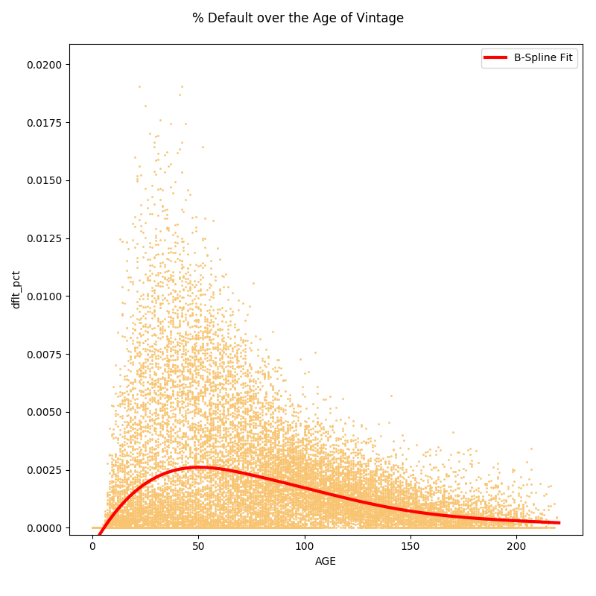  
The plot depicts an initial increase in the number of loans that default followed by a decrease in the occurrence of defaults. This ‘filtering effect’ is explained by the fact that as a batch of loans ages, the quality of the leftover loans increases on average. This behavior is observed in almost all vintages and the vintage model implemented in this paper exploits this phenomenon by aggregating loans that originate in the same period.

## Low Default

The percentage of loans that default given any batch of loans is often too low for a simple classification model to work effectively. For example, of ~12,000 loans that originated in the first quarter of 2010, only 2% or 240 loans defaulted within a period of about 8 years. Even when loans are aggregated by vintage, the number of months where no loans in the vintage default is too high for a regression model to reasonably predict the exposure at default. Thus, as explained below, we take a two step approach where we separate the problems of predicting when loans default (default event) and how much they default (exposure).

## Independent Variables

The data has 3 groups of independent variables:

1. Age
   * Average loan default rates grow from a low level to a peak, say, six months after origination, before tapering off as only the best risks remain on the books
2. Loan quality
   * These include the origination characteristics of the loan, such as initial rate, loan-to-value ratio and credit score. With vintage analysis, we take a weighted average of these variables.
3. Economic and risk drivers
   * The economic environment has a significant impact on loan default. Variables such as GDP growth rate, interest rate and inflation will be included.
   * There are three broad classes of economic variables:
     1. overall level of economic activity (e.g., the unemployment rate, the rate of inflation, and the NBER recession indicator)
     2. the direction in which the economy is moving (e.g., the growth rates of GDP and industrial production)
     3. conditions in the financial markets (e.g., interest rates and stock market returns) (Figlewski)

Details of the available variables is presented next.

## Variable Description

* Categorical
  + ORIG_CHN: Origination Channel - Channel refers to three options: Retail (R), Correspondent (C), Broker (B)
  + PURPOSE: Loan Purpose - An indicator that denotes w hether the mortgage loan is either a refinance mortgage or a purchase money mortgage. Purpose may be the purchase of a new property or refinance of an existing lien (w ith cash out or with no cash out).
  + PROP_TYP: Property Type - A field that denotes w hether the property type securing the mortgage loan is a cooperative share, condominium, planned urban development, single-family home, or manufactured home.
  + OCC_STAT: Occupancy Status - An indicator that denotes w hether the mortgage loan, at its origination date, is secured by a principal residence, second home or investment property.
  + MI_TYPE: Mortgage Insurance Type - The entity that is responsible for the Mortgage Insurance premium payment.
  + RELOCATION_FLG: Relocation Mortgage Indicator - An indicator that denotes w hether or not the type of mortgage loan is a relocation mortgage loan, made to borrow ers w hose employers relocate their employees.
* Numerical
  + ORIG_RT: Original Interest Rate - The original interest rate on a mortgage loan as identified in the original mortgage loan documents.
  + ORIG_TRM: Original Loan Term - The number of months in w hich regularly scheduled borrow er payments are due under the terms of the related mortgage documents.
  + OCLTV: Original Combined Loan-to-Value - A ratio calculated at the time of origination for a mortgage loan. The CLTV reflects the loan-to-value ratio inclusive of all loans secured by a mortgaged property on the origination date of the underlying mortgage loan.
  + NUM_BO: Number of Borrowers - The number of individuals obligated to repay the mortgage loan.
  + DTI: Debt to Income Ratio - A ratio calculated at origination derived by dividing the borrower’s total monthly obligations (including housing expense) by his or her stable monthly income. This calculation is used to determine the mortgage amount for w hich a borrower qualifies.
  + NUM_UNIT: Number of Units - The number of units comprising the related mortgaged property.
  + MI_PCT: Mortgage Insurance Percentage
  + CSCORE_MN: Credit Score at Origination - A numerical value used by the financial services industry to evaluate the quality of borrower credit. Credit scores are typically based on a proprietary statistical model that is developed for use by credit data repositories. These credit repositories apply the model to borrower credit information to arrive at a credit score. When this term is used by Fannie Mae, it is referring to the “classic” FICO score developed by Fair Isaac Corporation.
* Macro series
  + CPI: Consumer Price Index for All Urban Consumers: All Items (CPIAUCSL)
  + IR: Interest Rates, Discount Rate for United States (INTDSRUSM193N)
  + UNEMP: Unemployment Rate: Aged 15-64: All Persons for the United States
  + rGDP: Real Gross Domestic Product (GDPC1)
  + LIBOR: 1-Month London Interbank Offered Rate, based on U.S. Dollar (USD1MTD156N)
  + MR: 30-Year Fixed Rate Mortgage Average in the United States (MORTGAGE30US)
  + HPI: S&P/Case-Shiller U.S. National Home Price Index (CSUSHPISA)

## Vintage Aggregation

Our analysis begins with aggregating loans by vintage. We are free to choose the time interval of the vintage and will use monthly periods. In other words, loans that originate in the same month of the same year are grouped together as one vintage. Each loan has different characteristics. To describe a vintage of loans, we take a weighted average of these characteristics (both continuous and categorical) weighed by the original amount of each loan. Consequently, loans of larger dollar value have a relatively greater impact on the overall quality of the vintage. No such averaging is necessary with economic variables because every loan in a vintage originates in the same period and thus, faces identical economic conditions.

## Dependent Variable

What we ultimately want to predict is the net loss ratio in period t. Net loss ratio is defined as

$${Net loss ratio}_{t}={{Net loss due to defaulted loans}_{t}}/{{Total original amount of vintage}_{0}}$$

Note the denominator is known at time of origination and is thus subscripted by 0. We break the problem of forecasting the net loss ratio into three parts:

$$E\left({Net Loss ratio}_{t}\right)=P\left({\text{Default event}}_{t}\right)∙E\left({\% of original amount that defaults}_{t} | {\text{Default event}}_{t}\right)∙E\left({\% of default amount that is lost}_{t} | {\% of original amount that defaults}_{t}\right)$$

In words, we first identify those months when a vintage experiences a default event. When any loan in the vintage defaults, this is considered a default event. Then, given a default event has occurred, we estimate how much of the original amount has defaulted. Lastly, we calculate what percentage of this amount is lost after taking into account proceeds and cost of resale. Subsequently, we will call the three parts of the model as stages 1,2 and 3, respectively.

## Example

Final output of the model is the percentage of a vintage’s original balance expected to be lost (ie. % of original balance that defaults plus any proceeds from resale/modification). To illustrate the methodology, below we discuss a simplified example. The columns are:

* ORIG_DTE: Year and month in which loans were originated (ie. vintage)
* ORIG_AMT: Aggregate original amount loaned for each vintage
* Net loss ratio: % of ORIG_AMT that was lost (net of proceeds) in each subsequent month (Month 0 is the month the loans were originated). Negative value if there was a gain due to default.

|  |  |  |  |  |  |  |
| --- | --- | --- | --- | --- | --- | --- |
| **ORIG_DTE** | **ORIG_AMT** |  | **Net loss ratio** | |  |  |
|  | **Loan age ->** | **Month 0** | **Month 1** | **Month 2** | **Month 3** | **Month 4** |
| 2018Q2 | 500000 |  |  |  |  |  |
| 2018Q1 | 1000000 | 0.10% |  |  |  |  |
| 2017Q4 | 800000 | 0.00% | 0.23% |  |  |  |
| 2017Q3 | 700000 | 0.05% | 0.00% | 1.00% |  |  |
| 2017Q2 | 1100000 | 0.00% | 0.00% | 0.04% | 0.00% |  |
| 2017Q1 | 900000 | 0.20% | 0.35% | 0.40% | 0.15% | 0.04% |

Data in the gray cells indicate the current period and we do not yet know how much was lost. Our goal is to project losses for loans originated in 2018/2 (blue cells). We make the assumption that we can estimate net loss ratio in month X by taking some average of net loss ratios of previous loans in month X. For instance, we estimate the net loss ratio of 2018/2 loans in Month 1 by using the net loss ratio of 2017/12 and 2017/11 loans in Month 1 (0.23% and 0% respectively). Of course, as discussed, we have more data than just historical net loss ratios of past loans. Our full model will include these other variables.

# Gradient Boosting Classifier

Given a dataset with a response variable and a set of predictors, conventional regression models such as generalized additive models attempt to fit the most parsimonious model that is most effective in explaining the relationship between the variables. On the other hand, ensemble methods such as gradient boosted models fit many simple models and combine their predictions to produce a robust prediction of the response variable. In particular, a gradient boosting classifier (GBC) fits many simple regression trees with the goal of minimizing a given loss function (Leathwick, 2006).

Many advantages are offered by GBC over conventional methods including

1. Ability to accommodate both different types of predictor variables and missing values
2. Immunity to the effects of extreme outliers and the inclusion of irrelevant predictors
3. Facility for fitting complex. interactions between predictors

(Friedman and Meulman, 2003)

# Random Forest Regression

Bagging is a technique used to improve prediction accuracy. It does so by essentially reducing the variance of an estimated prediction function by bootstrapping on the training data. For example, in a regression problem, one can fit a regression tree multiple times on bootstrapped versions of the training set and take an average of the predictions. In this sense, it is quite similar to the gradient boosted models described above. Random forest methods can be seen as a modification of the bagging method. The idea behind random forests is to induce even greater variance reduction than bagging by reducing the correlation between the fitted trees, without increasing the variance too substantially. De-correlation is achieved during the tree-growing process by randomly selecting the input variables. When random forest is applied to a regression problem, it is called Random Forest Regression (RFR).

RFR is a powerful method for several reasons:

1. Requires comparatively little tuning in model parameters and variable selection
2. Relatively robust to overfitting when appropriate depth of the trees is set
3. Capable of capturing complex, nonlinear relationships between variables

(Hastie, Tibshirani and Friedman, 2009)

# Vintage Model Results

We reiterate the 3 stage vintage model described above. Stage 1 is a binary classification problem predicting which months a vintage experiences a default event (ie. has at least 1 defaulting loan). Stage 2 is a regression problem predicting the percentage of the original loan amounts that default on those months. Stage 3 predicts the percentage of the defaulted amount that is lost net of proceeds from resale of the loan. We use a GBC for the first stage and RFR for stages 2 and 3. We test our model on different subsets of the fannie mae data as well as data from LendingClub. The model specifications are specified separately for each scenario.

## Fannie Mae Mortgage Data: ~3,000

Data: ~3,000 loans from each month of 2000~2010

Train-Test split: 90-10% split based on vintage dates

Model specifications:

|  |  |  |  |  |  |
| --- | --- | --- | --- | --- | --- |
| **Stage 1 GBC** |  | **Stage 2 RFR** |  | **Stage 3 RFR** |  |
| **Parameter** | **Value** | **Parameter** | **Value** | **Parameter** | **Value** |
| learning_rate | 0.1 | bootstrap | False | bootstrap | True |
| max_depth | 3 | criterion | mse | criterion | mse |
| max_features | 0.5 | max_features | 0.333 | max_features | 0.1 |
| min_impurity_decrease | 0.0001 | min_impurity_decrease | 1e-10 | min_impurity_decrease | 1e-10 |
| n_estimators | 10 | n_estimators | 20 | n_estimators | 50 |
| subsample | 0.1 |  |  |  |  |

Selected variables:

AGE, rGDP, HPI, UNEMP, CPI, PURPOSE_R_wv, PURPOSE_R_wm, PURPOSE_P_wv, PURPOSE_P_wm, ORIG_RT_wv, ORIG_RT_wm, ORIG_CHN_R_wm, ORIG_CHN_C_wm, ORIG_AMT_sum, OCLTV_wv, OCLTV_wm, LOAN_ID_count, DTI_wv, DTI_wm, CSCORE_MN_wv, CSCORE_MN_wm

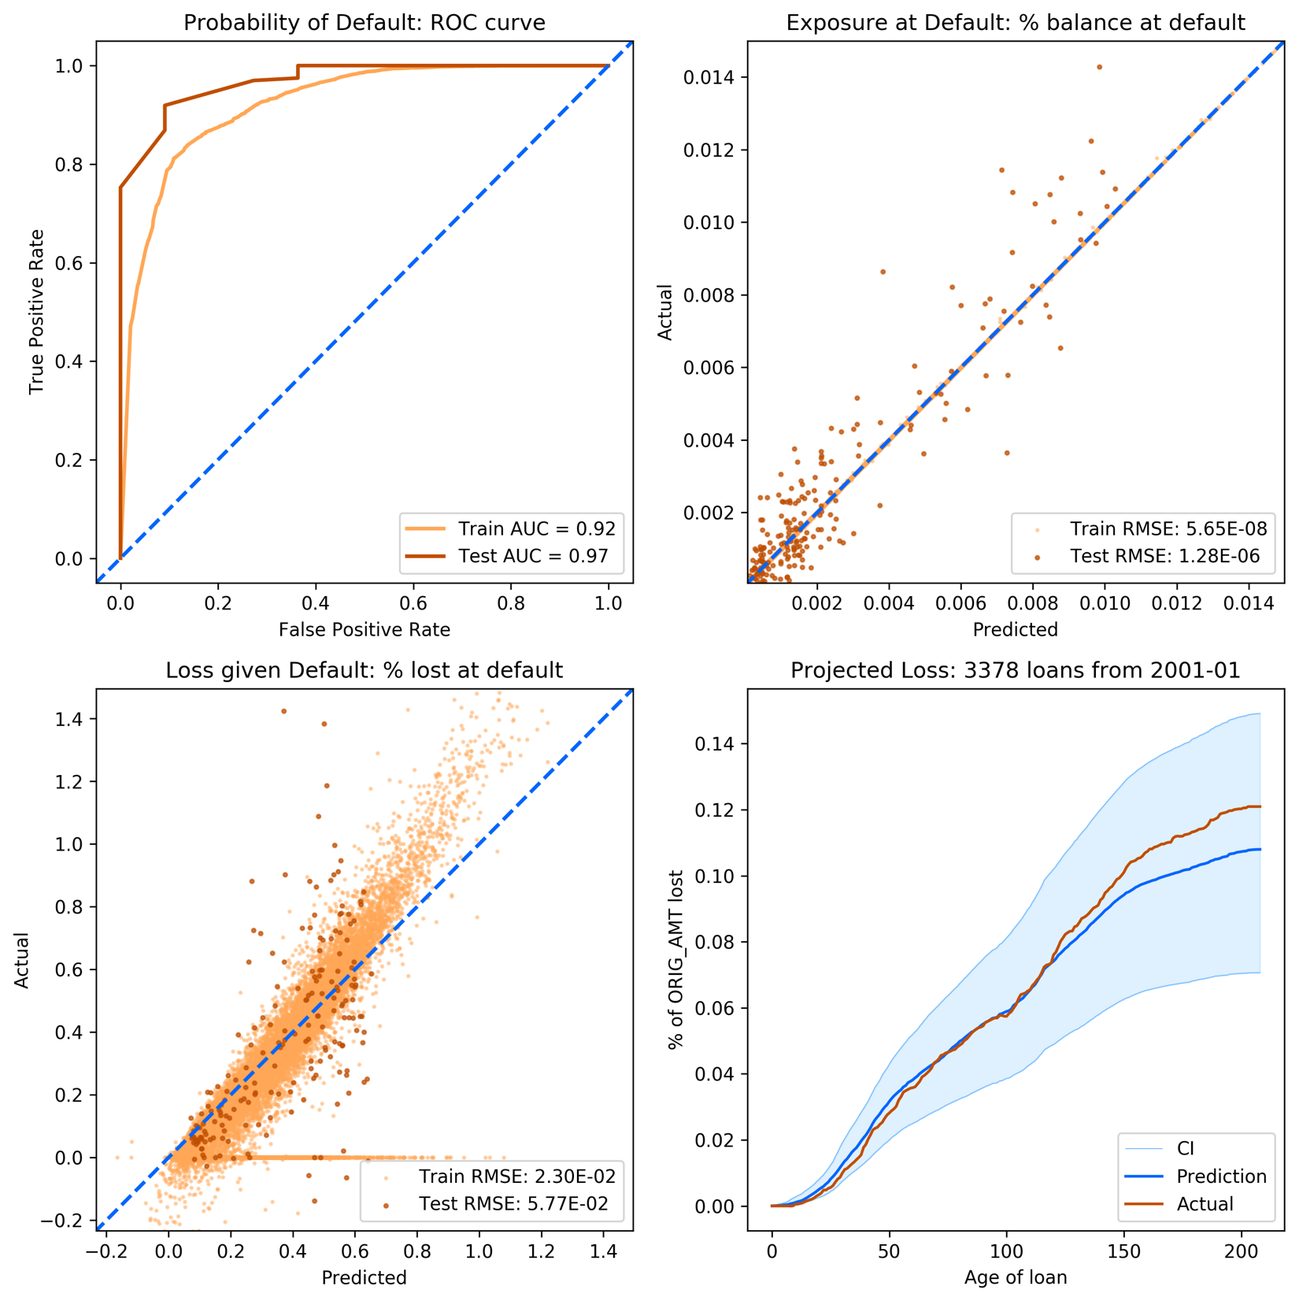

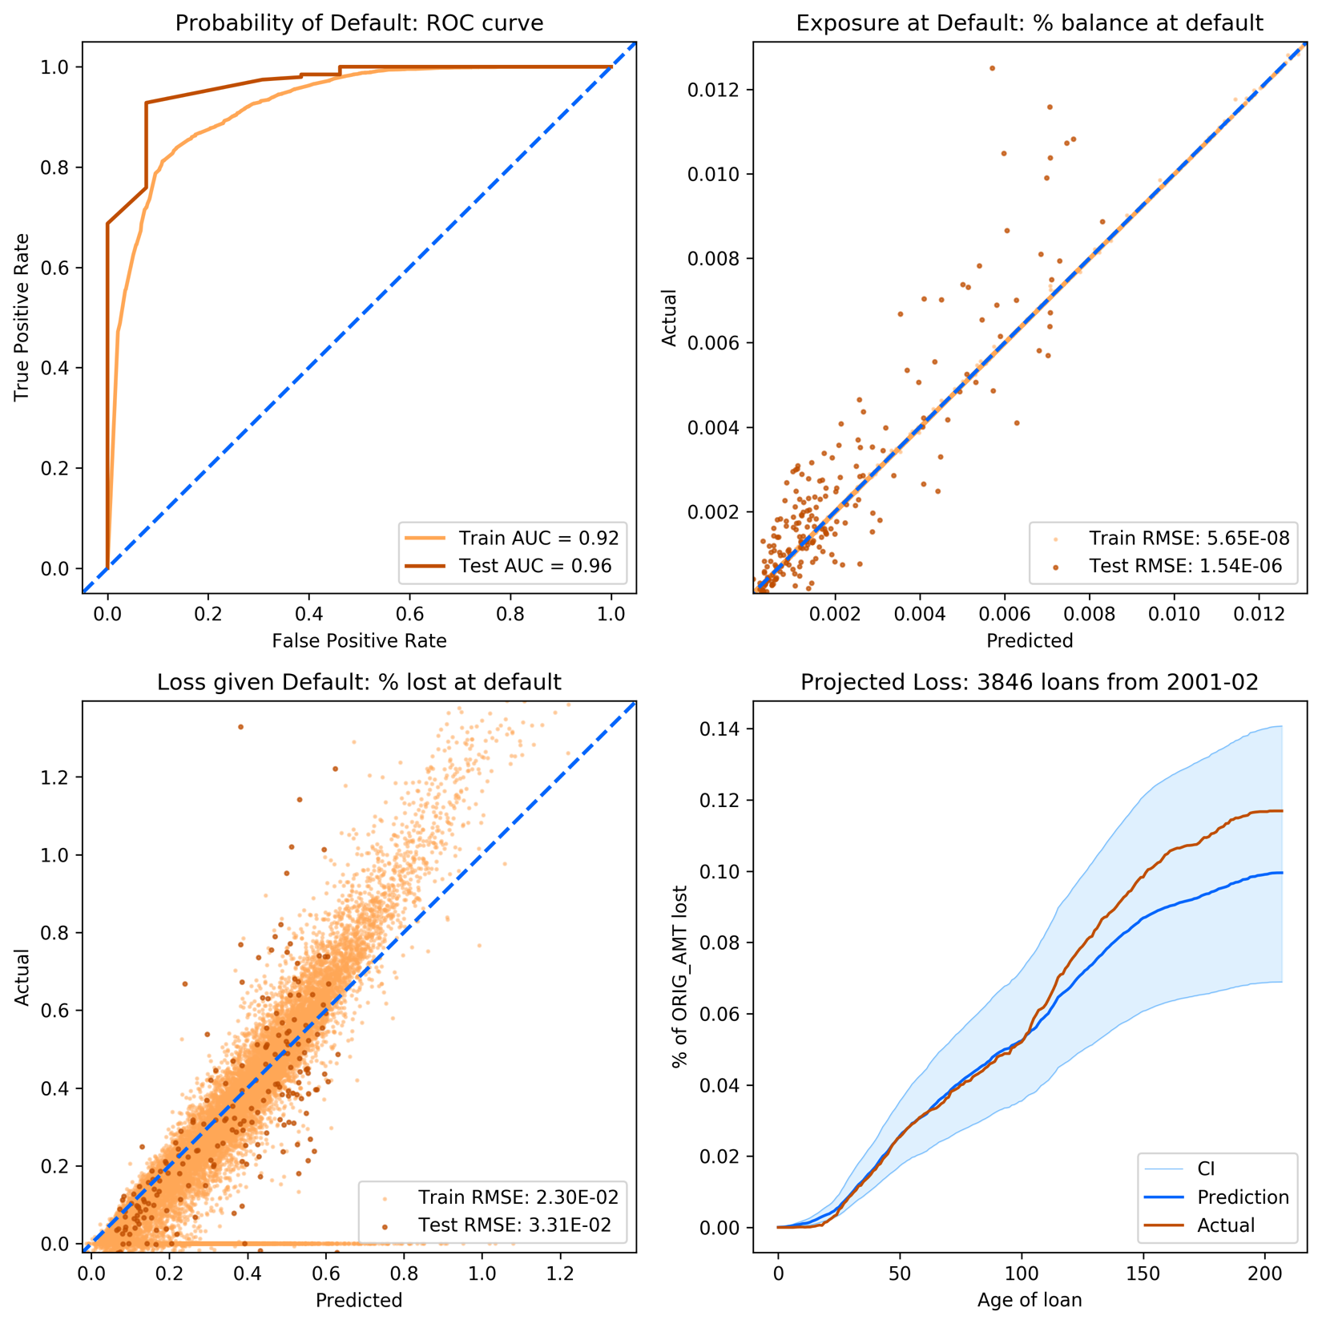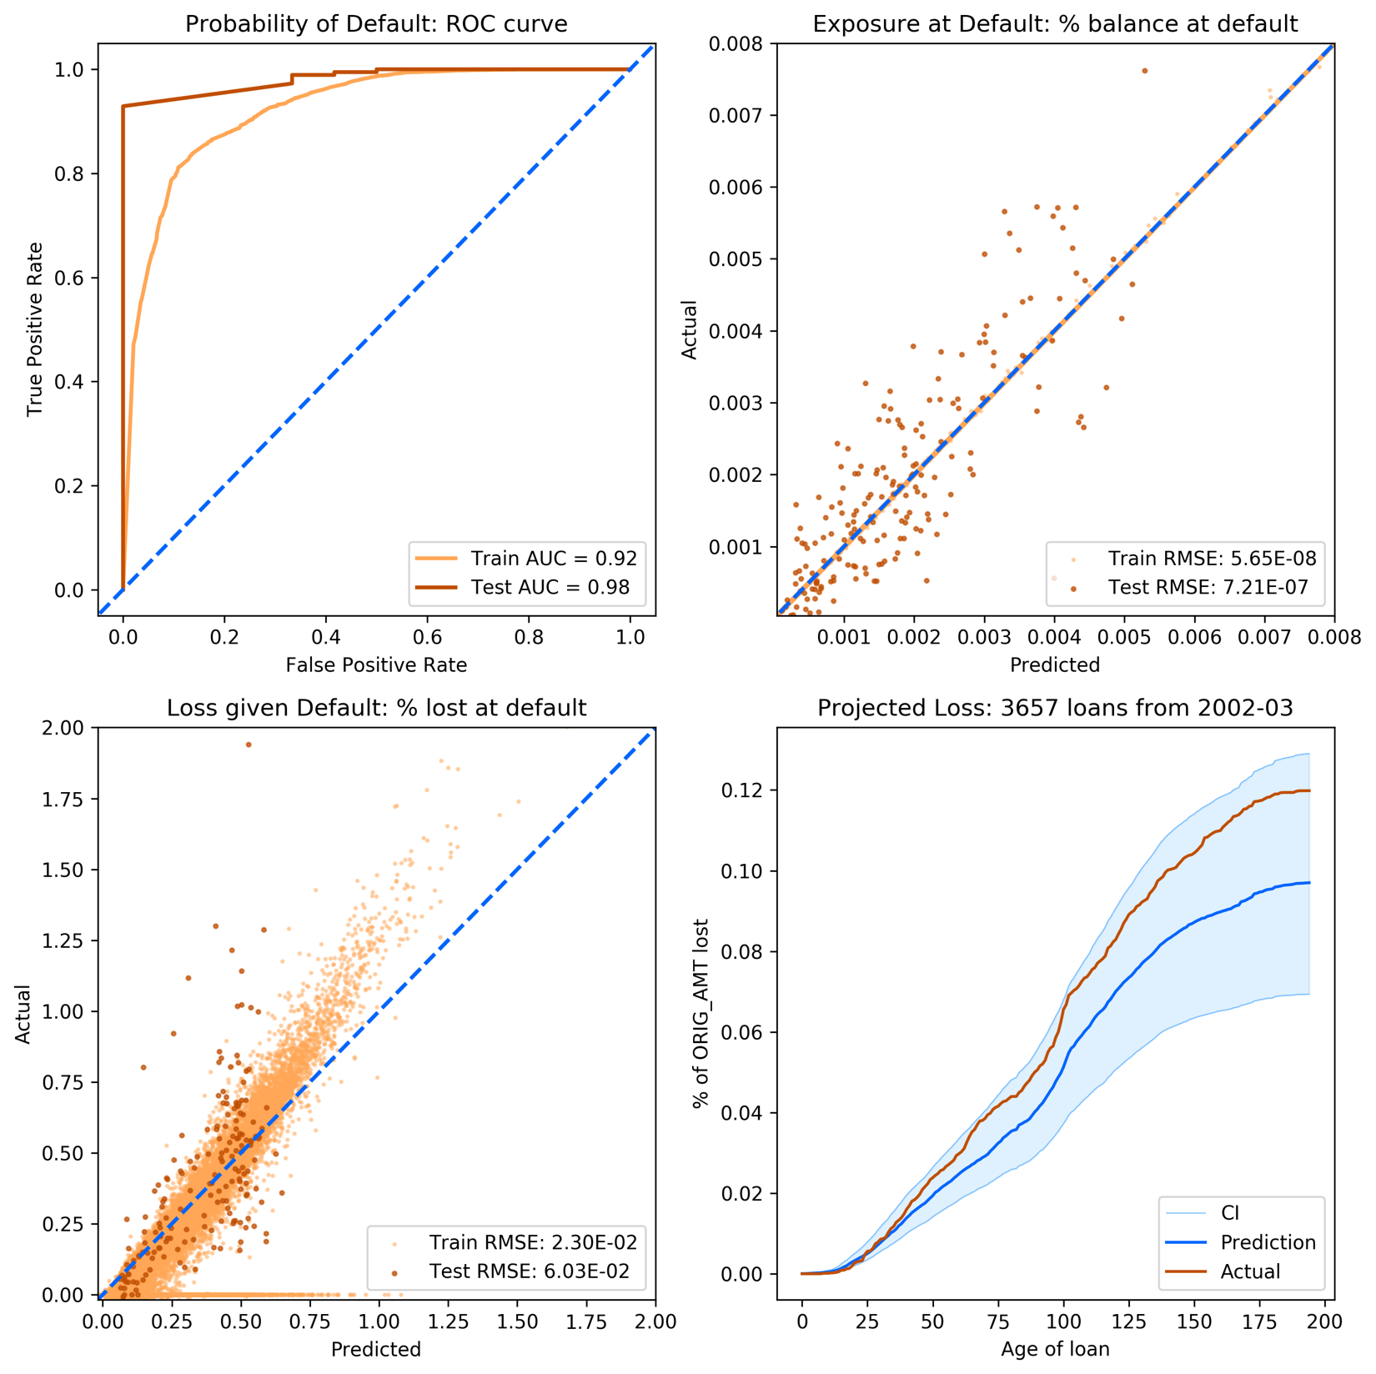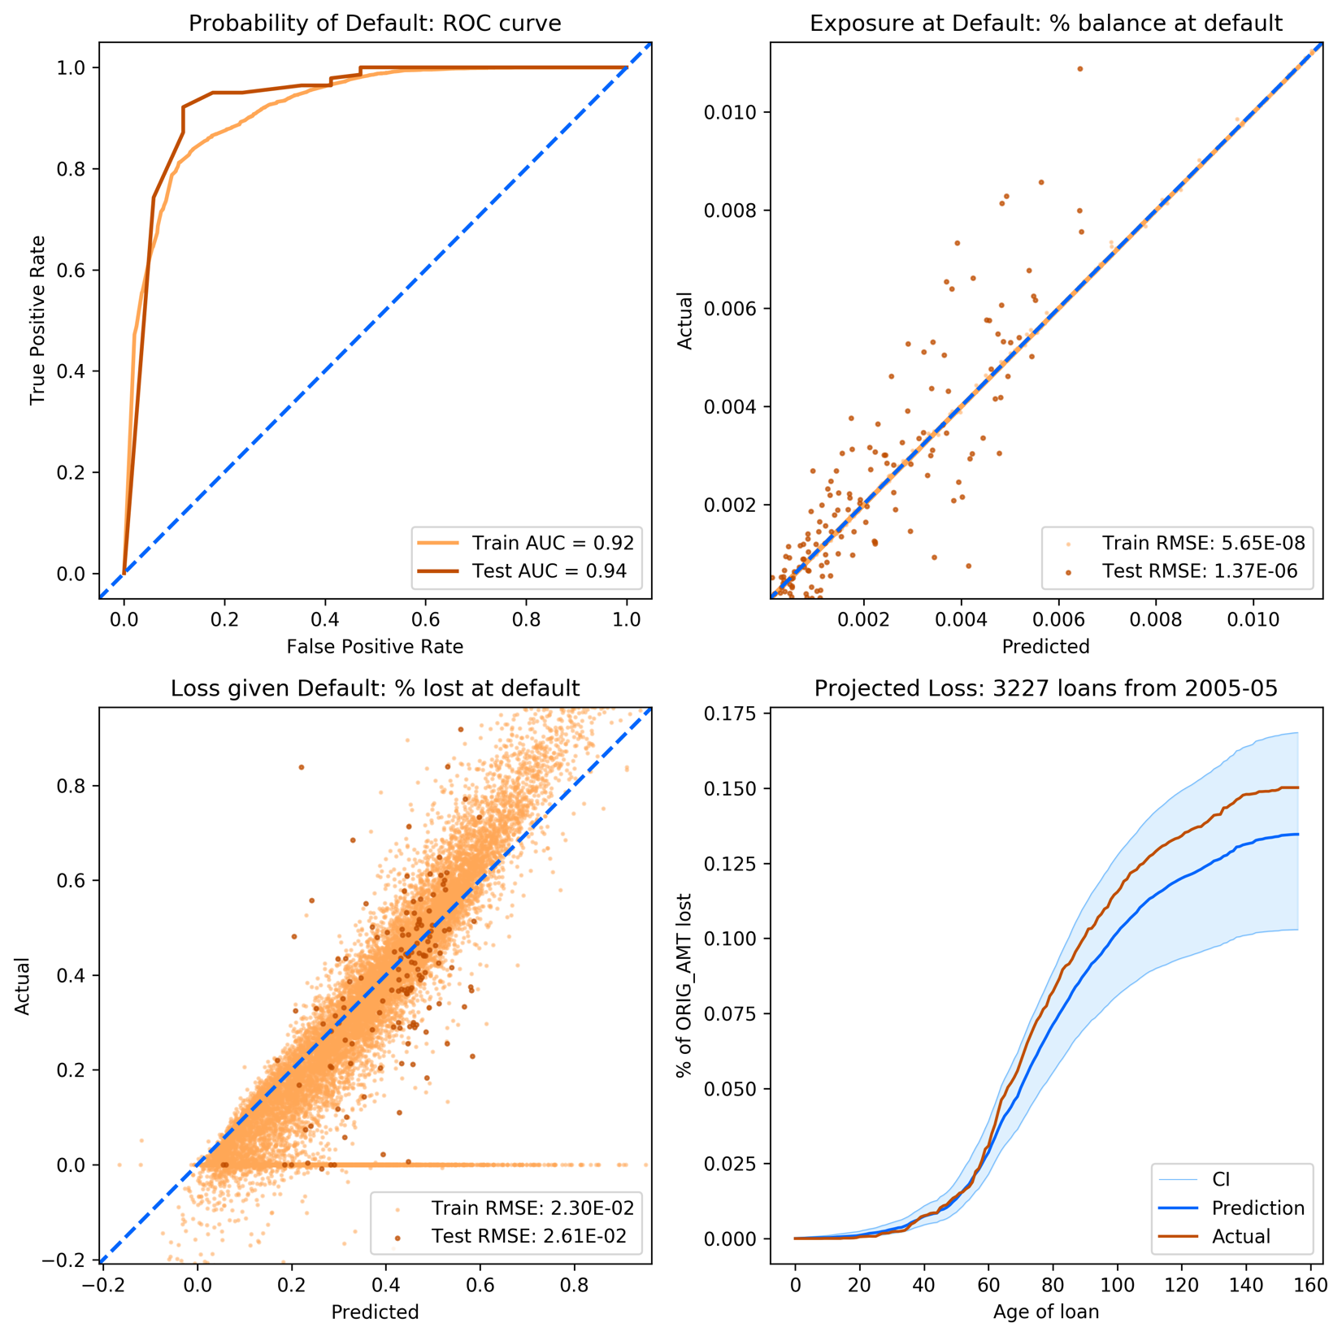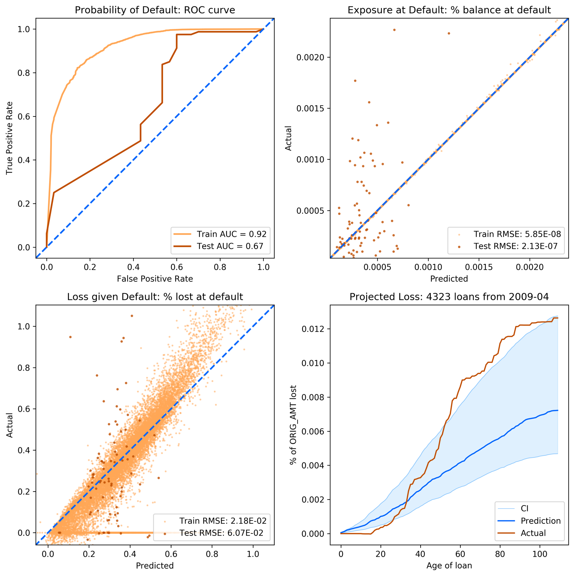

## Fannie Mae Mortgage Data: 1,000

Data: 1,000 loans from each month of 2000~2010

Train-Test split: 90-10% split based on vintage dates

Model specifications:

|  |  |  |  |  |  |
| --- | --- | --- | --- | --- | --- |
| **Stage 1 GBC** |  | **Stage 2 RFR** |  | **Stage 3 RFR** |  |
| **Parameter** | **Value** | **Parameter** | **Value** | **Parameter** | **Value** |
| learning_rate | 0.1 | bootstrap | False | bootstrap | True |
| max_depth | 3 | criterion | mse | criterion | mse |
| max_features | 0.5 | max_features | 0.333 | max_features | 0.1 |
| min_impurity_decrease | 0.0001 | min_impurity_decrease | 1e-10 | min_impurity_decrease | 1e-10 |
| n_estimators | 10 | n_estimators | 20 | n_estimators | 50 |
| subsample | 0.1 |  |  |  |  |

Selected variables:

AGE, rGDP, HPI, UNEMP, CPI, PURPOSE_R_wv, PURPOSE_R_wm, PURPOSE_P_wv, PURPOSE_P_wm, ORIG_RT_wv, ORIG_RT_wm, ORIG_CHN_R_wm, ORIG_CHN_C_wm, ORIG_AMT_sum, OCLTV_wv, OCLTV_wm, LOAN_ID_count, DTI_wv, DTI_wm, CSCORE_MN_wv, CSCORE_MN_wm

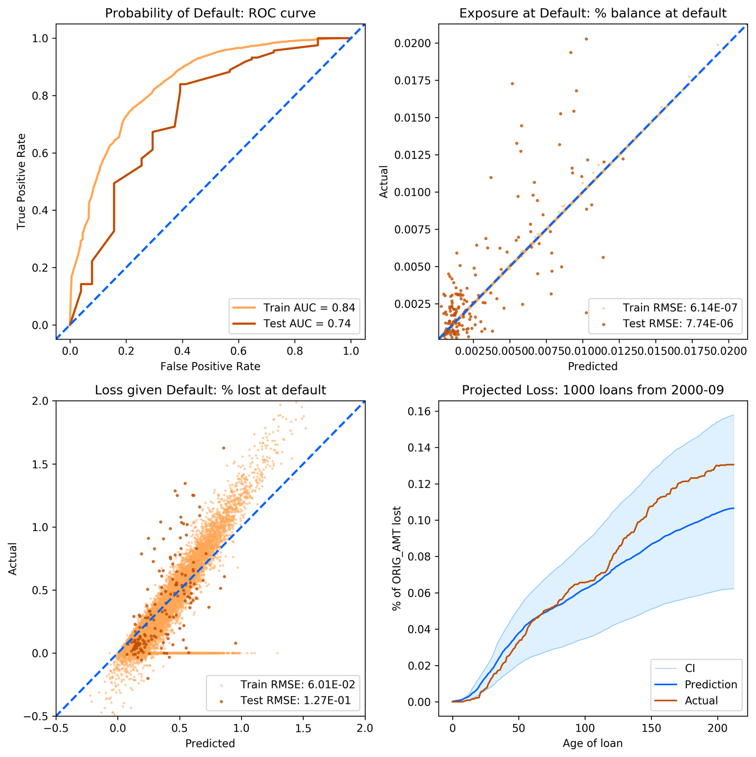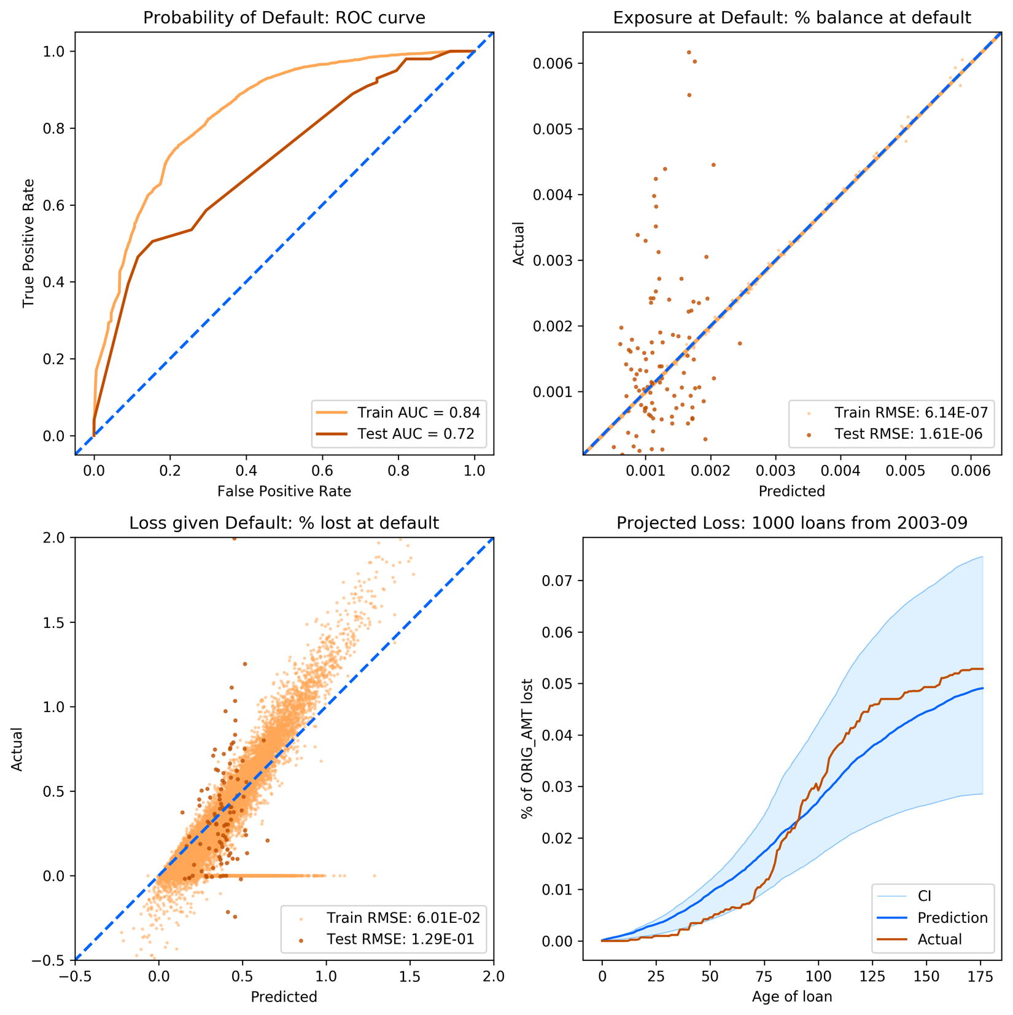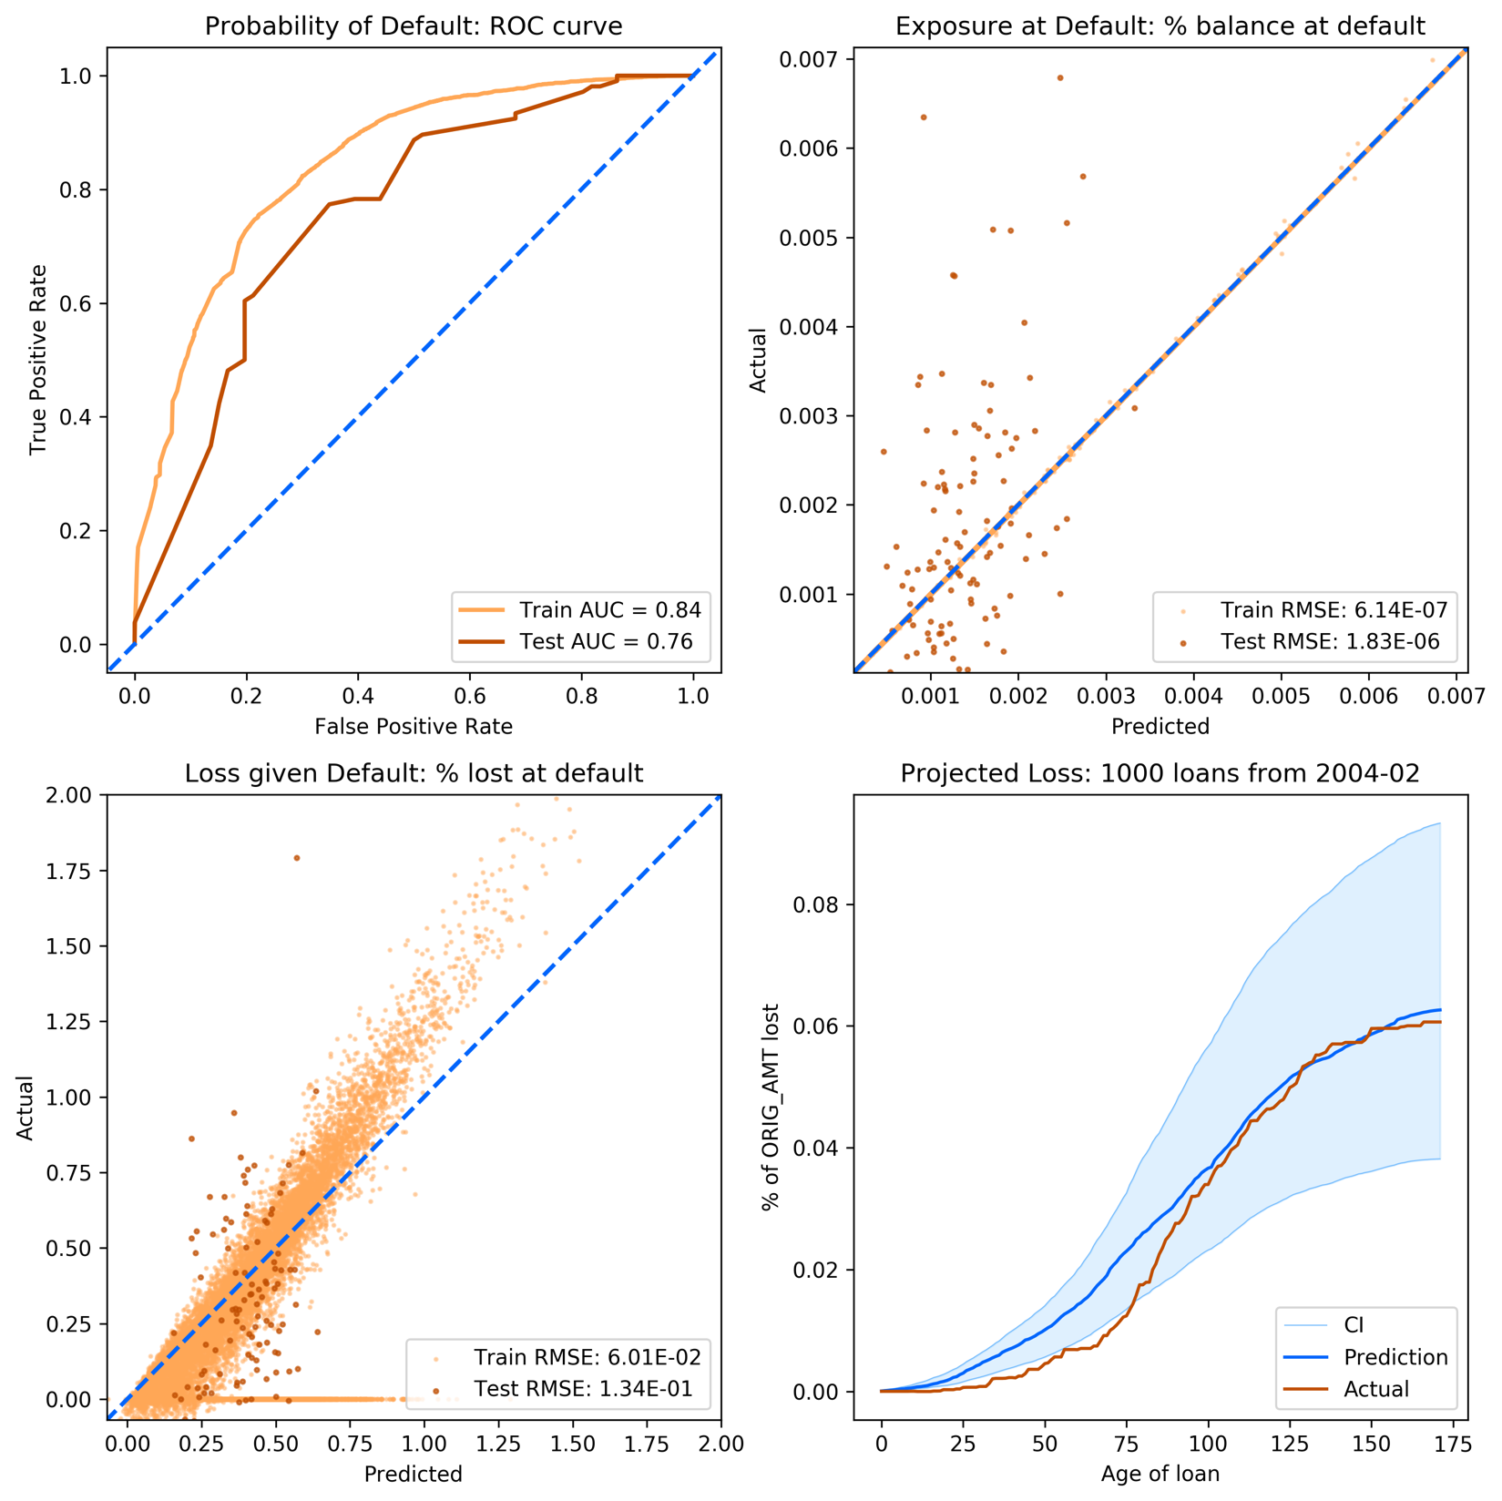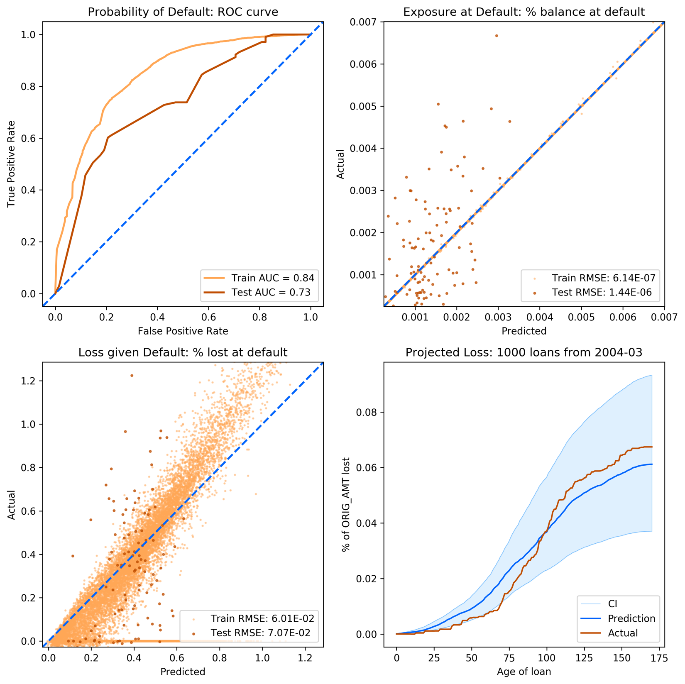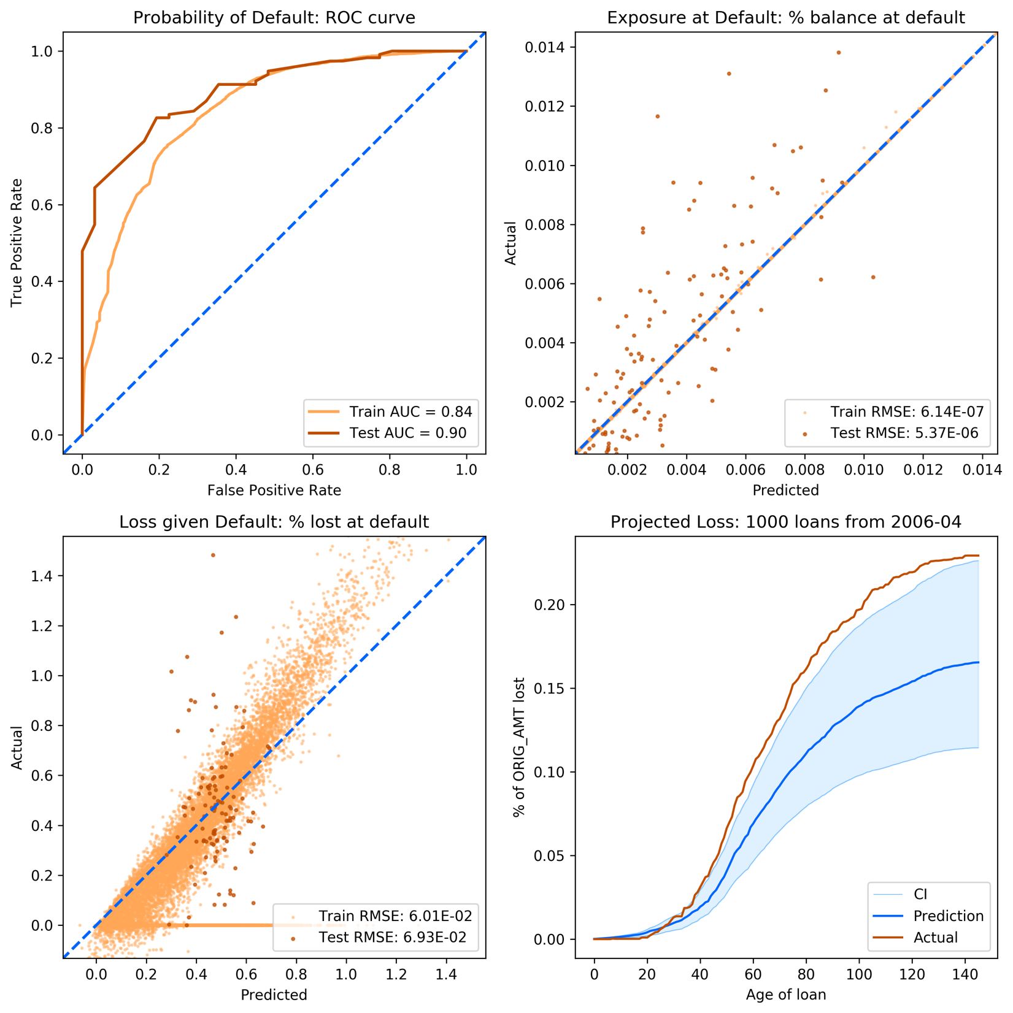

## Fannie Mae Mortgage Data: Post-recession

Data: ~3,500 loans from each month of Mid 2009~2010

Train-Test split: 90-10% split based on vintage dates

Model specifications:

|  |  |  |  |  |  |
| --- | --- | --- | --- | --- | --- |
| **Stage 1 GBC** |  | **Stage 2 RFR** |  | **Stage 3 RFR** |  |
| **Parameter** | **Value** | **Parameter** | **Value** | **Parameter** | **Value** |
| learning_rate | 0.1 | bootstrap | False | bootstrap | True |
| max_depth | 3 | criterion | mse | criterion | mse |
| max_features | 0.5 | max_features | 0.333 | max_features | 0.1 |
| min_impurity_decrease | 0.0001 | min_impurity_decrease | 1e-10 | min_impurity_decrease | 1e-10 |
| n_estimators | 10 | n_estimators | 20 | n_estimators | 50 |
| subsample | 0.1 |  |  |  |  |

Selected variables:

AGE, rGDP, HPI, UNEMP, CPI, PURPOSE_R_wv, PURPOSE_R_wm, PURPOSE_P_wv, PURPOSE_P_wm, ORIG_RT_wv, ORIG_RT_wm, ORIG_CHN_R_wm, ORIG_CHN_C_wm, ORIG_AMT_sum, OCLTV_wv, OCLTV_wm, LOAN_ID_count, DTI_wv, DTI_wm, CSCORE_MN_wv, CSCORE_MN_wm

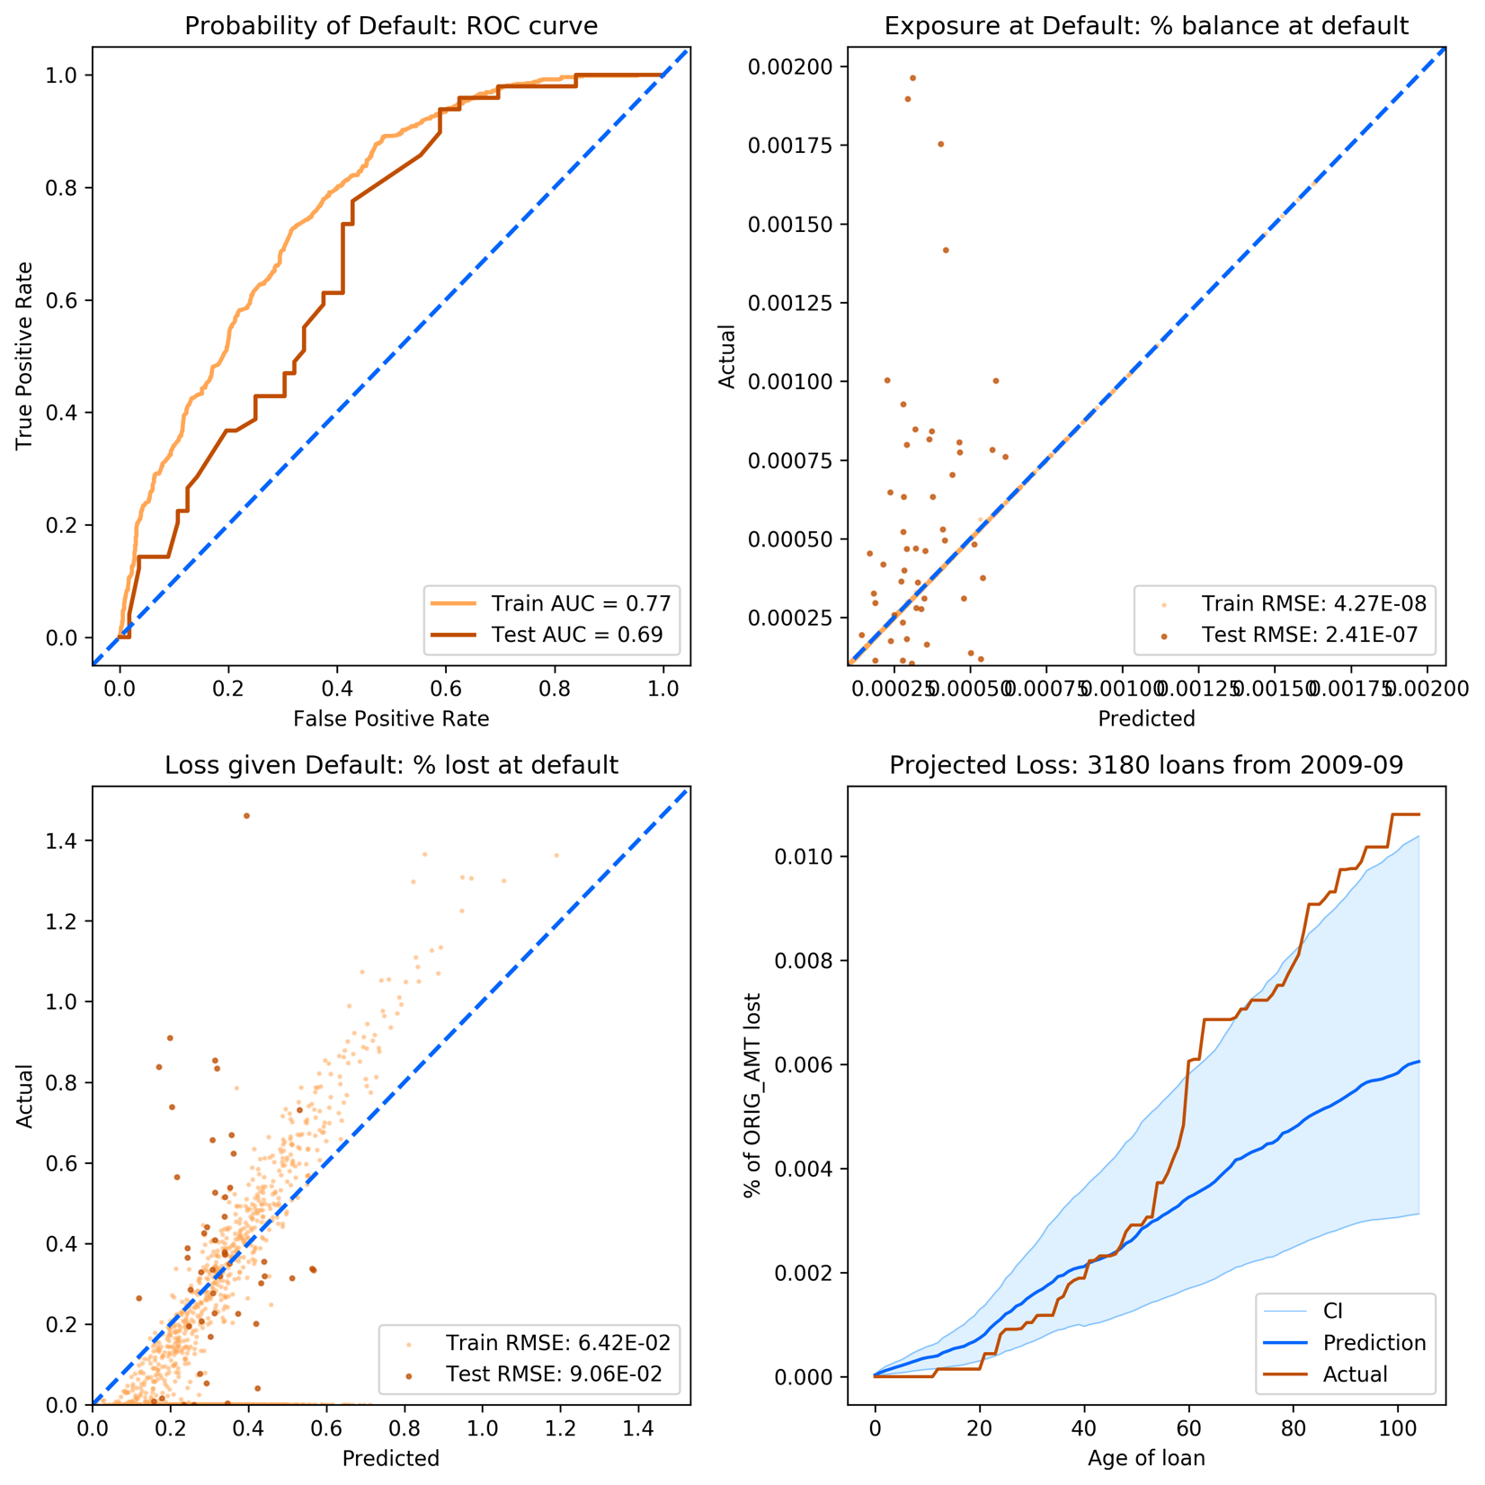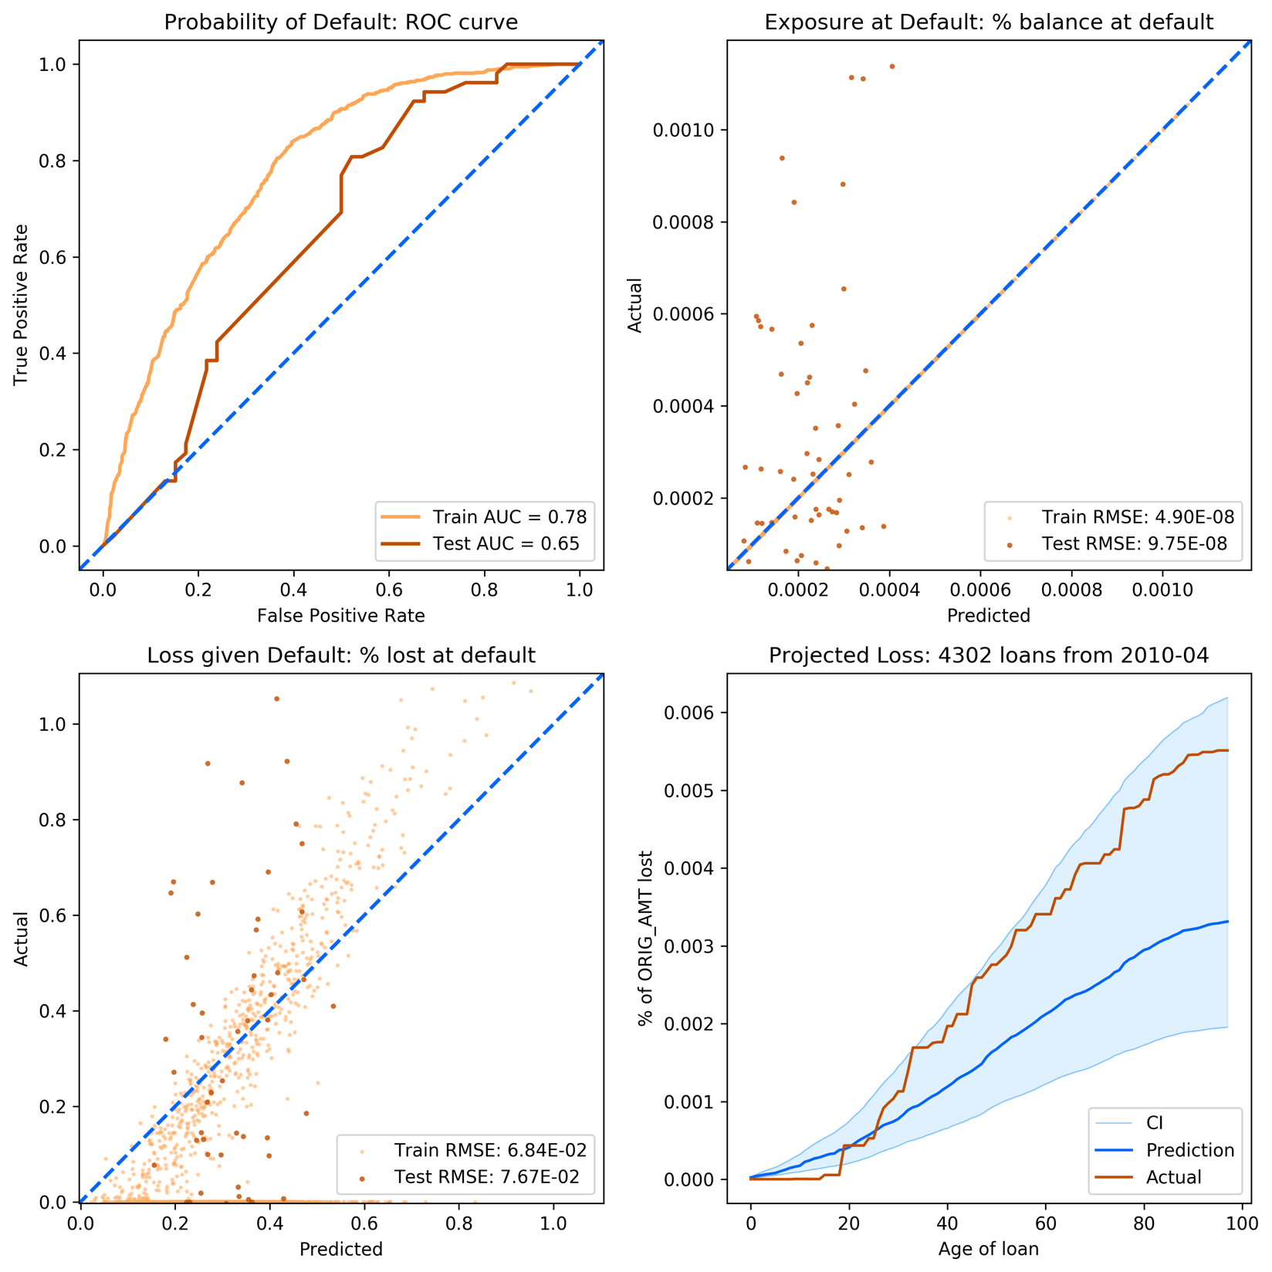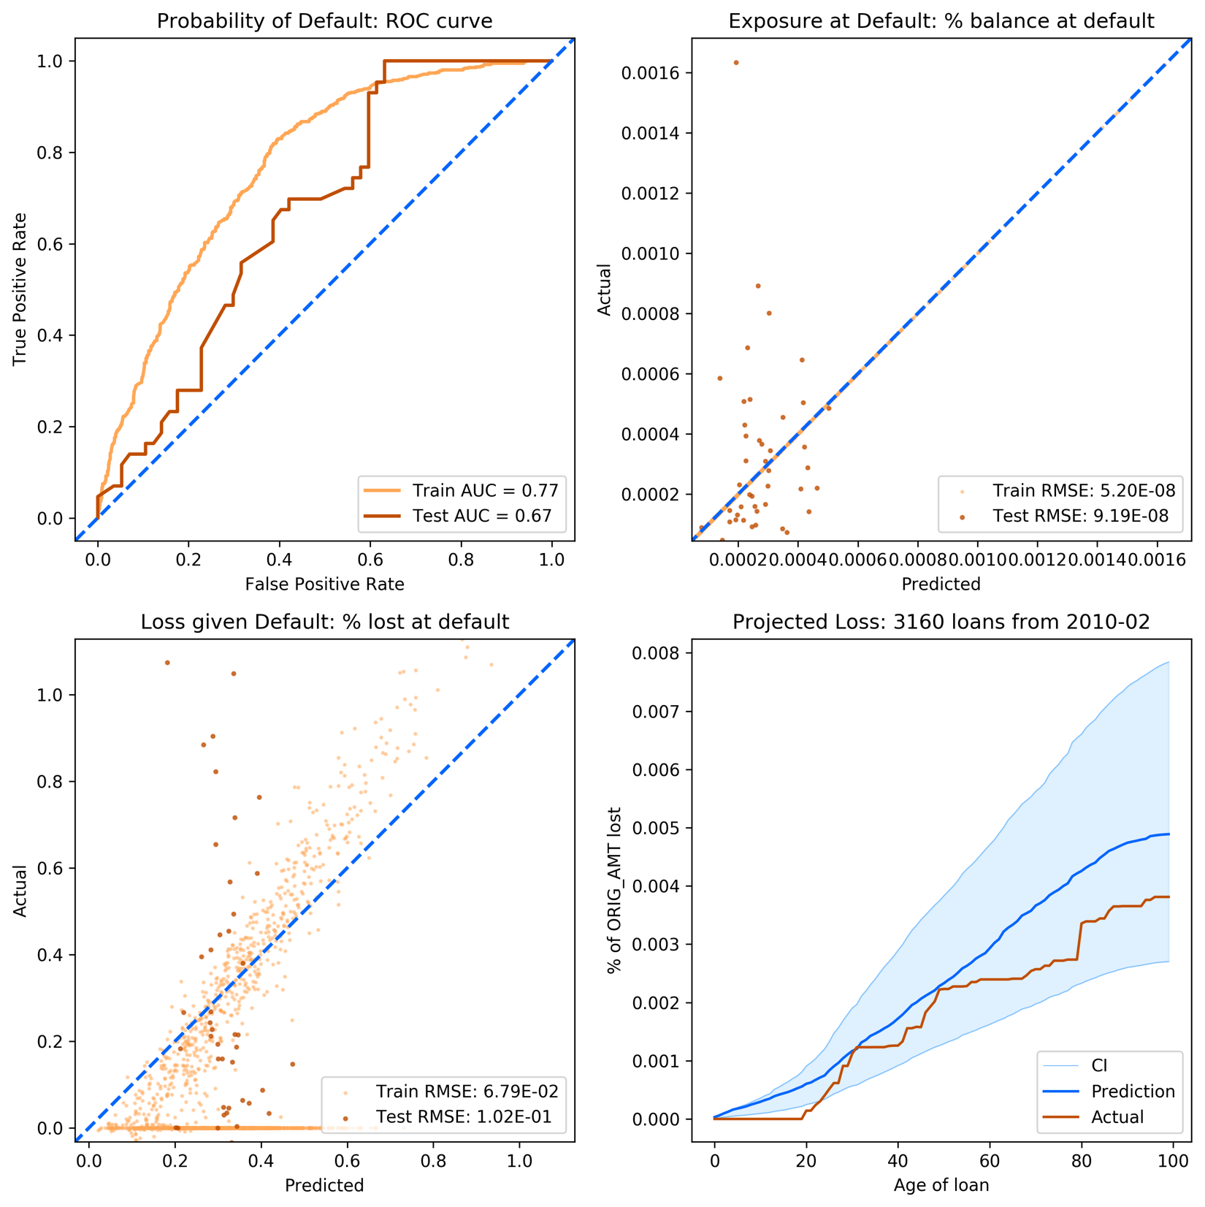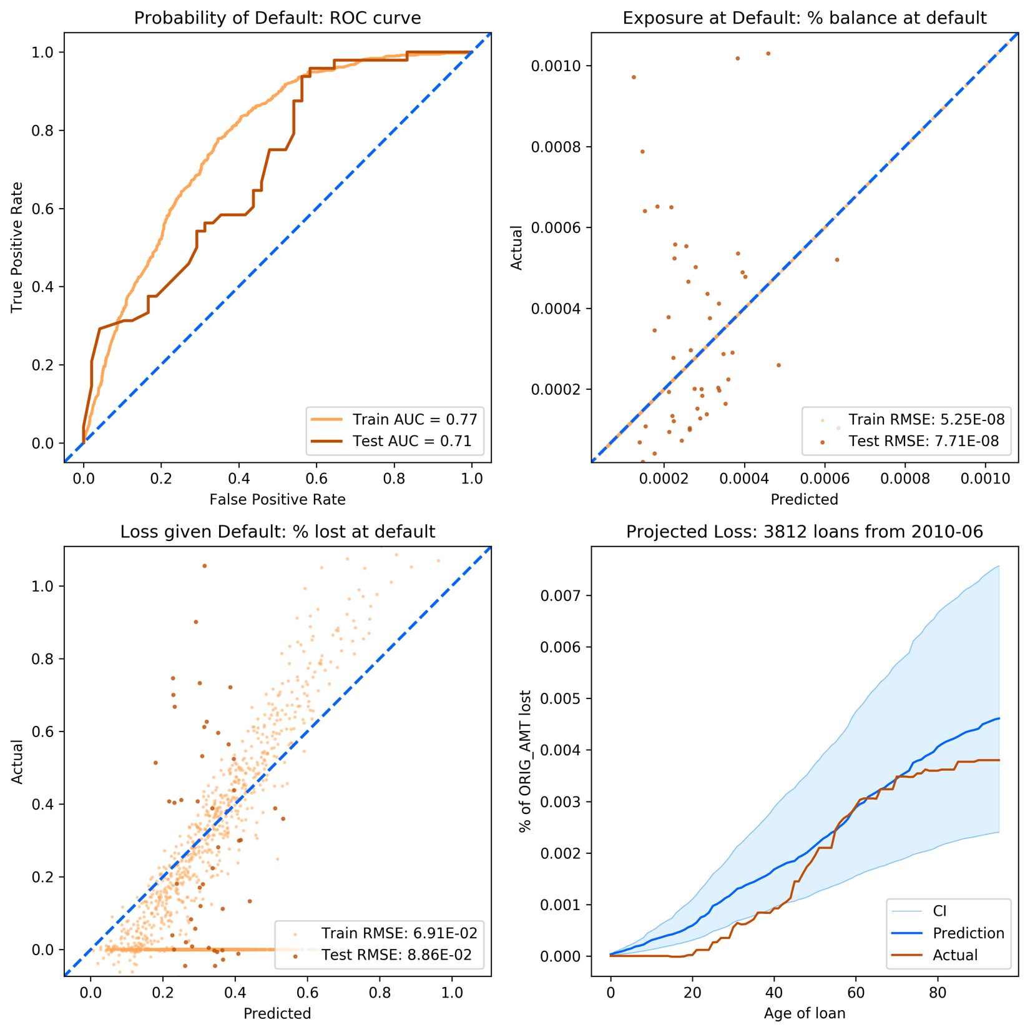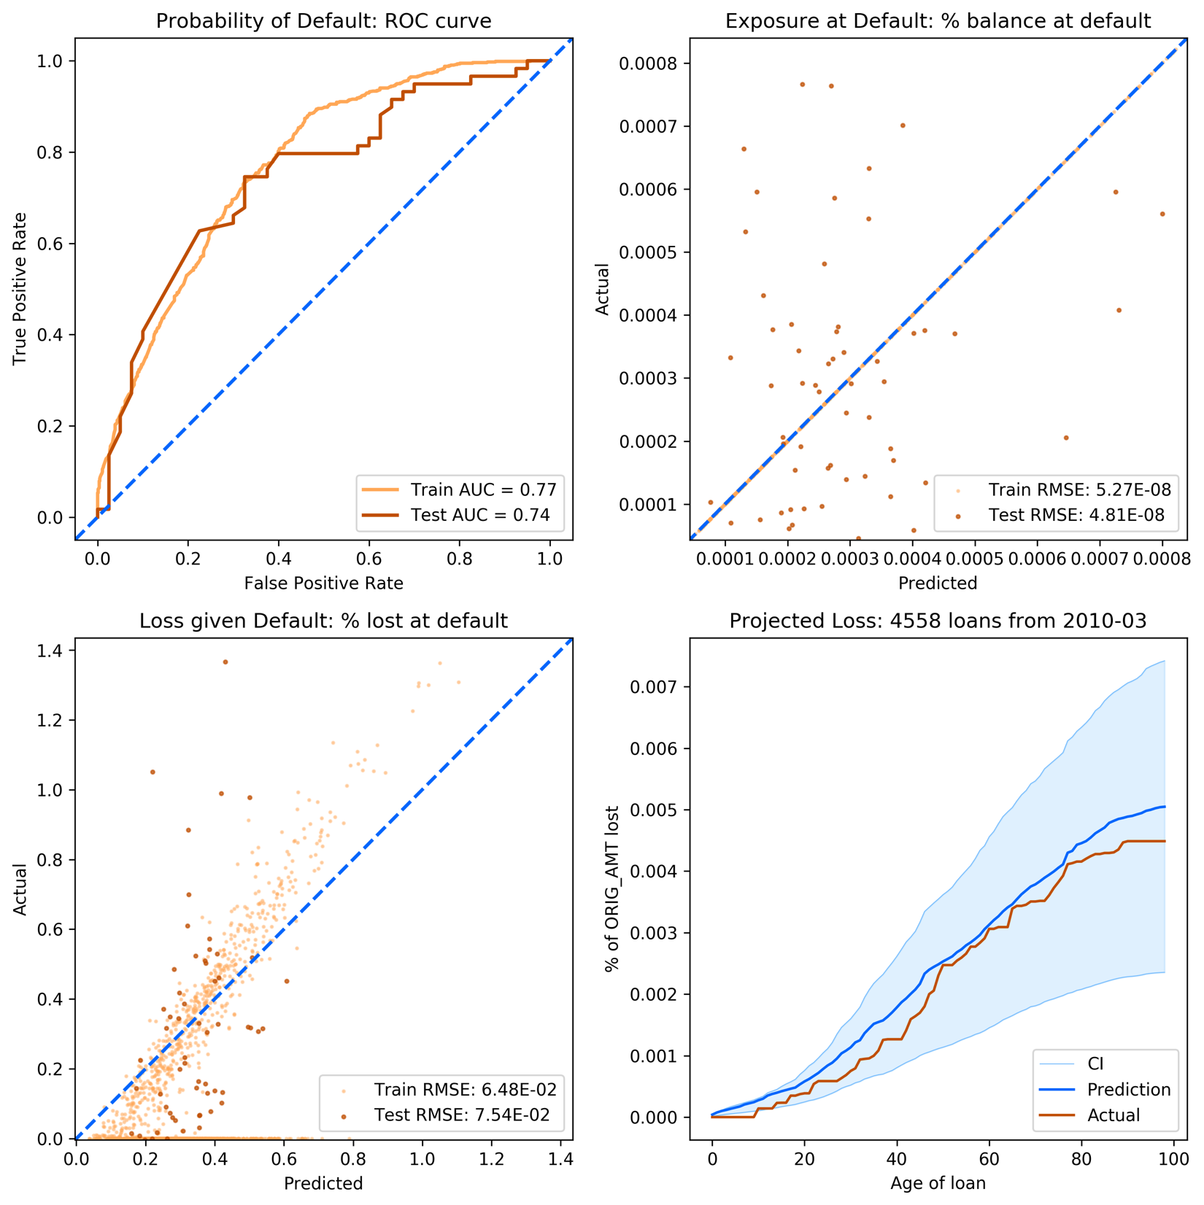

## LendingClub Data: Debt Consolidation

Data: Average of 386 loans from each quarter of 2007~2011 (min: 24, max: 1208)

Train-Test split: 90-10% split based on vintage dates

Model specifications:

|  |  |  |  |  |  |
| --- | --- | --- | --- | --- | --- |
| **Stage 1 GBC** |  | **Stage 2 RFR** |  | **Stage 3 RFR** |  |
| **Parameter** | **Value** | **Parameter** | **Value** | **Parameter** | **Value** |
| learning_rate | 0.1 | bootstrap | False | bootstrap | True |
| max_depth | 3 | criterion | mse | criterion | mse |
| max_features | 0.5 | max_features | 0.333 | max_features | 0.1 |
| min_impurity_decrease | 0.0001 | min_impurity_decrease | 1e-10 | min_impurity_decrease | 1e-10 |
| n_estimators | 10 | n_estimators | 20 | n_estimators | 50 |
| subsample | 0.1 |  |  |  |  |

Selected variables:

AGE , UNEMP, HPI, rGDP, CPI, MR, LIBOR , ORIG_AMT_sum, LOAN_ID_count, DTI_wm, ORIG_RT_wm, ORIG_RT_wv, DTI_wv, CSCORE_MN_wv, CSCORE_MN_wm

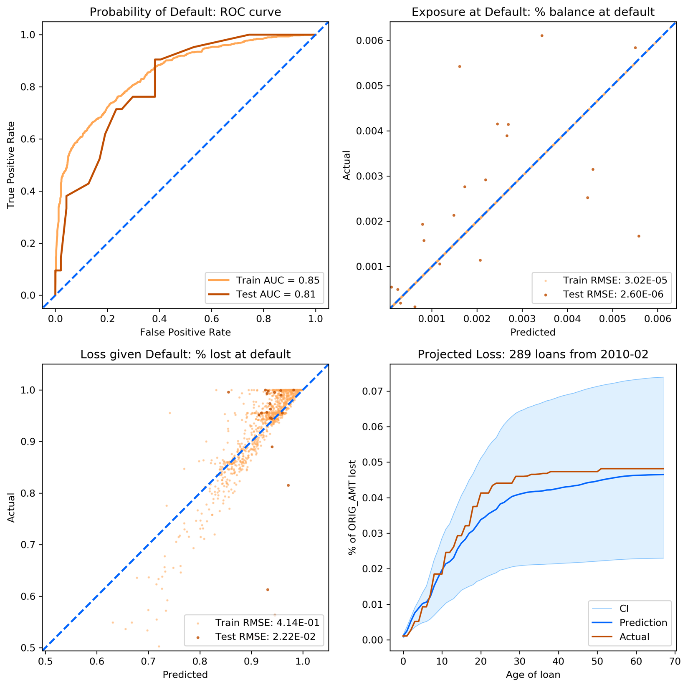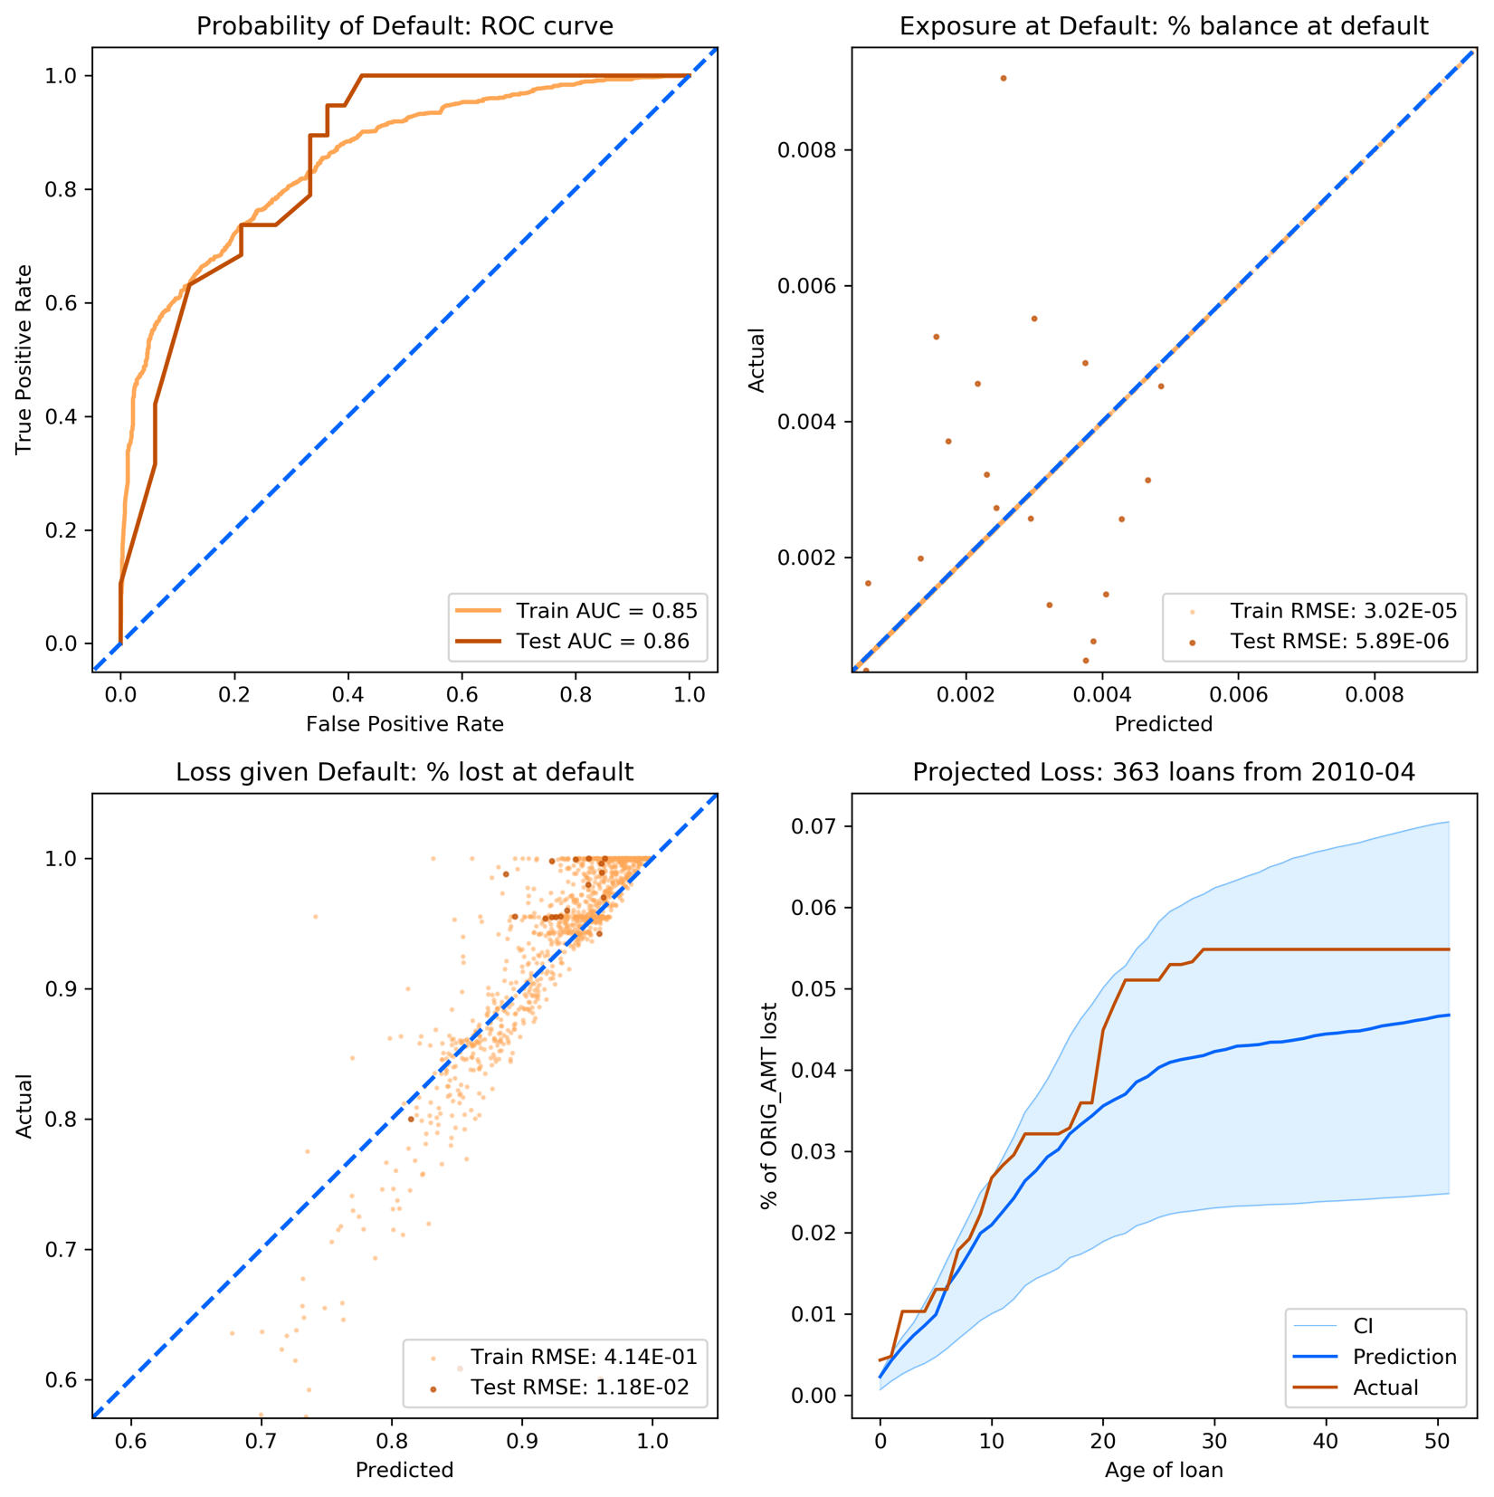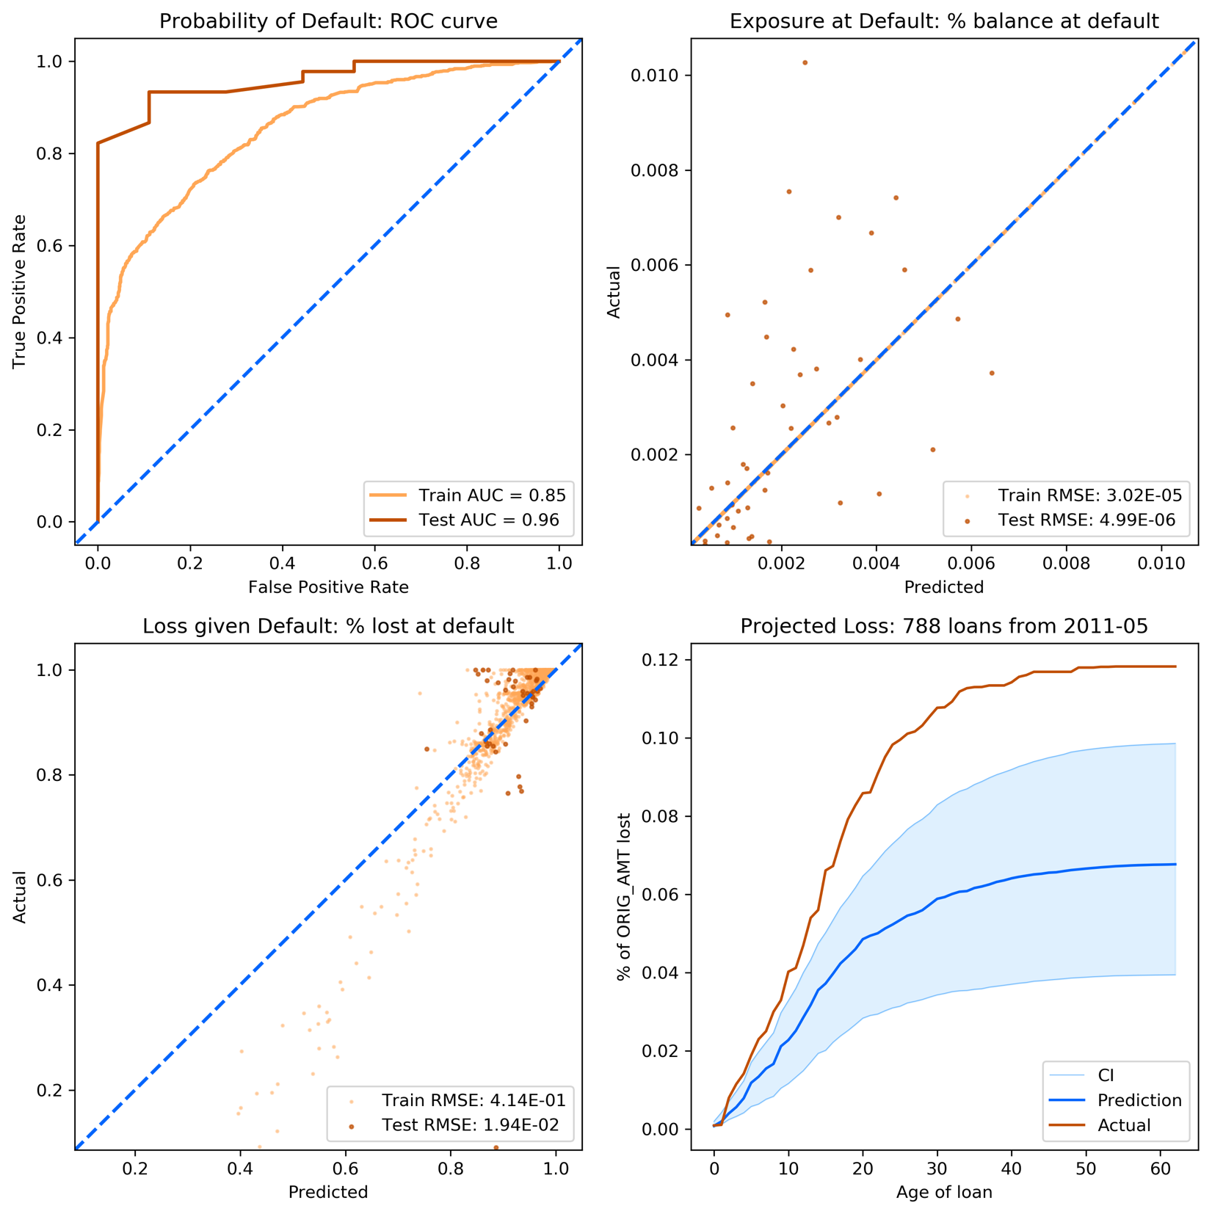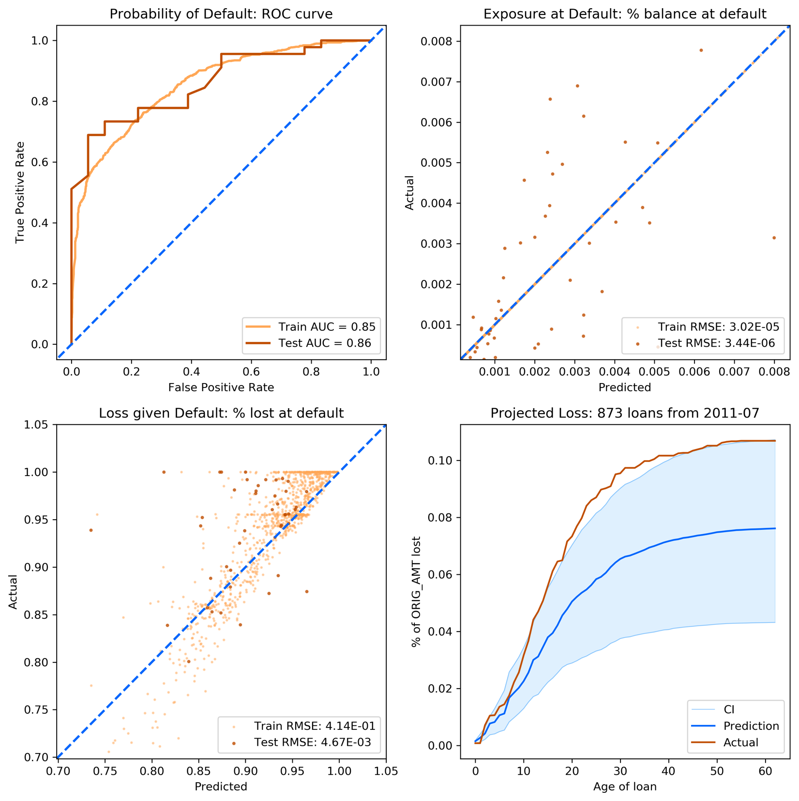

## LendingClub Data: Car Loans

Data: Average of 32 loans from each quarter of 2007~2011 (min: 1, max: 106)

Train-Test split: 90-10% split based on vintage dates

Model specifications:

|  |  |  |  |  |  |
| --- | --- | --- | --- | --- | --- |
| **Stage 1 GBC** |  | **Stage 2 RFR** |  | **Stage 3 RFR** |  |
| **Parameter** | **Value** | **Parameter** | **Value** | **Parameter** | **Value** |
| learning_rate | 0.1 | bootstrap | False | bootstrap | True |
| max_depth | 3 | criterion | mse | criterion | mse |
| max_features | 0.5 | max_features | 0.333 | max_features | 0.1 |
| min_impurity_decrease | 0.0001 | min_impurity_decrease | 1e-10 | min_impurity_decrease | 1e-10 |
| n_estimators | 10 | n_estimators | 20 | n_estimators | 50 |
| subsample | 0.1 |  |  |  |  |

Selected variables:

AGE , UNEMP, HPI, rGDP, CPI, MR, LIBOR , ORIG_AMT_sum, LOAN_ID_count, DTI_wm, ORIG_RT_wm, ORIG_RT_wv, DTI_wv, CSCORE_MN_wv, CSCORE_MN_wm

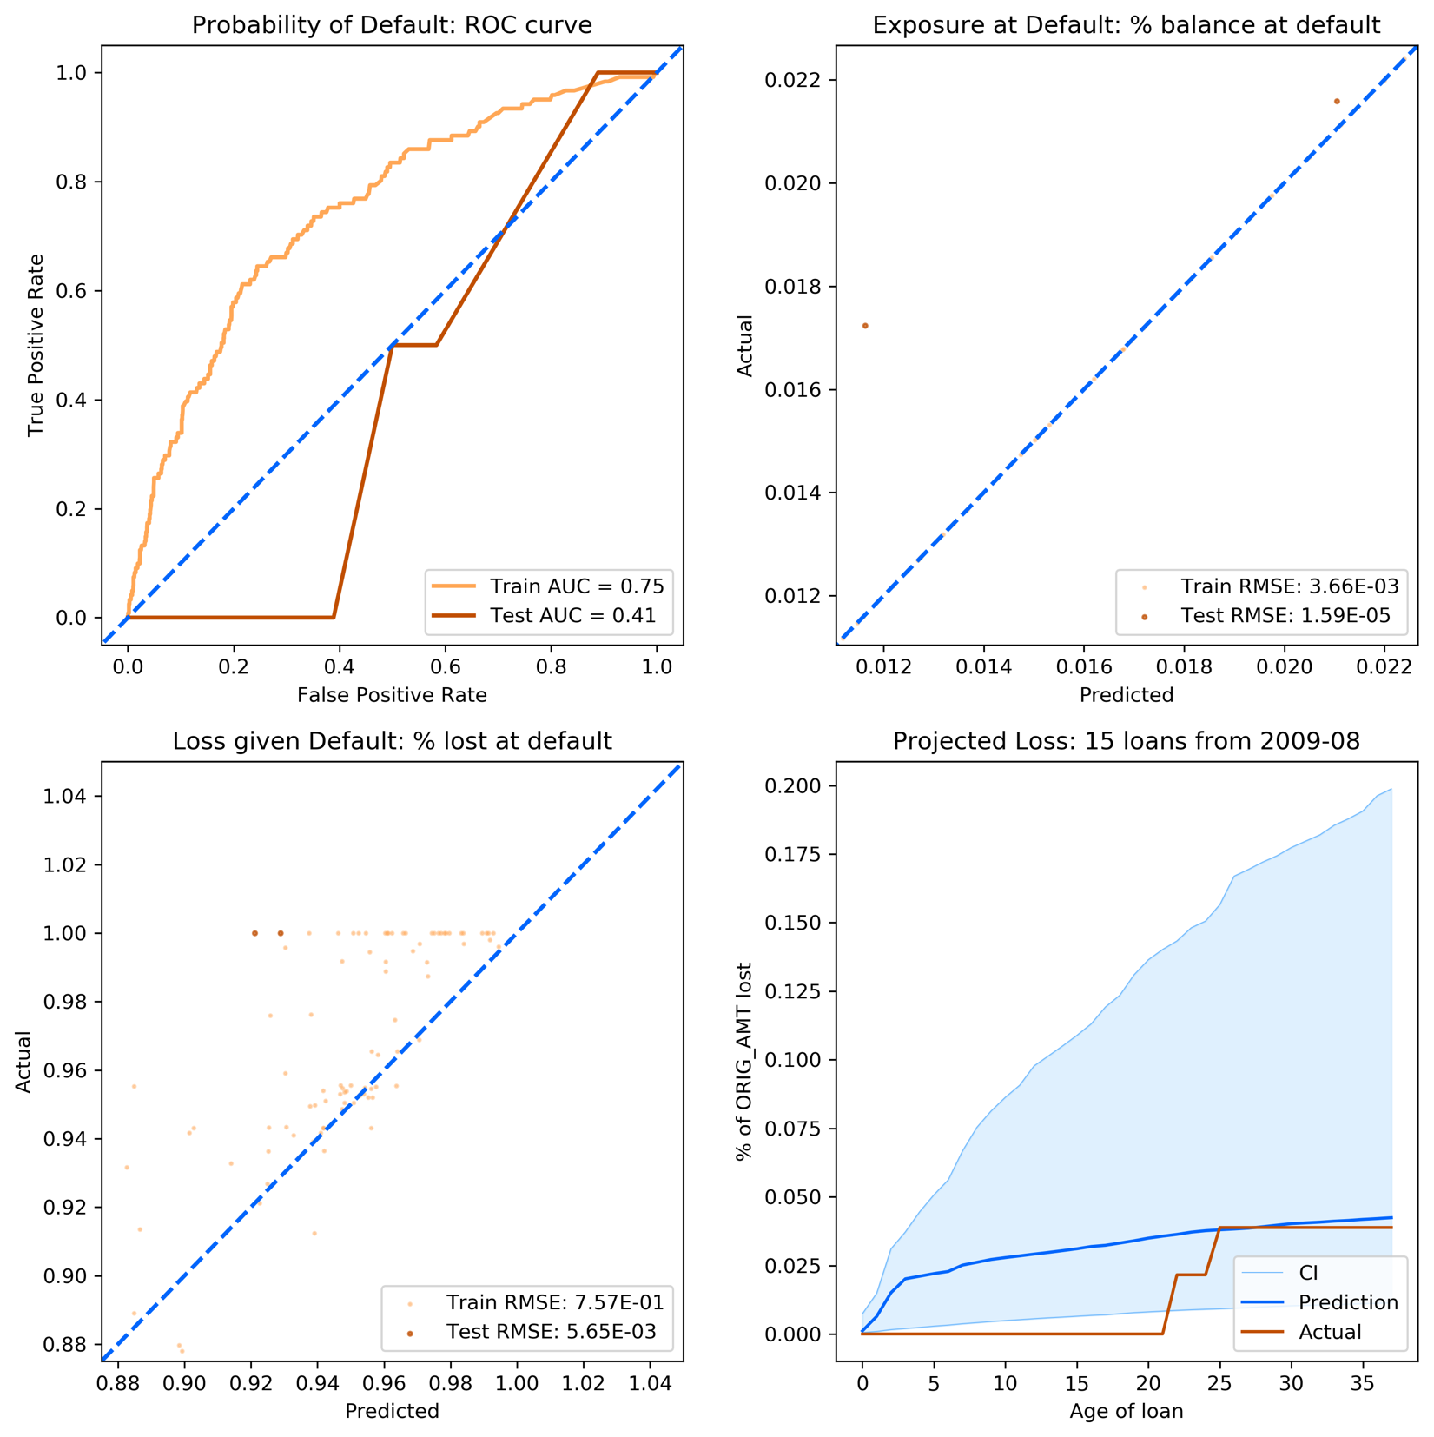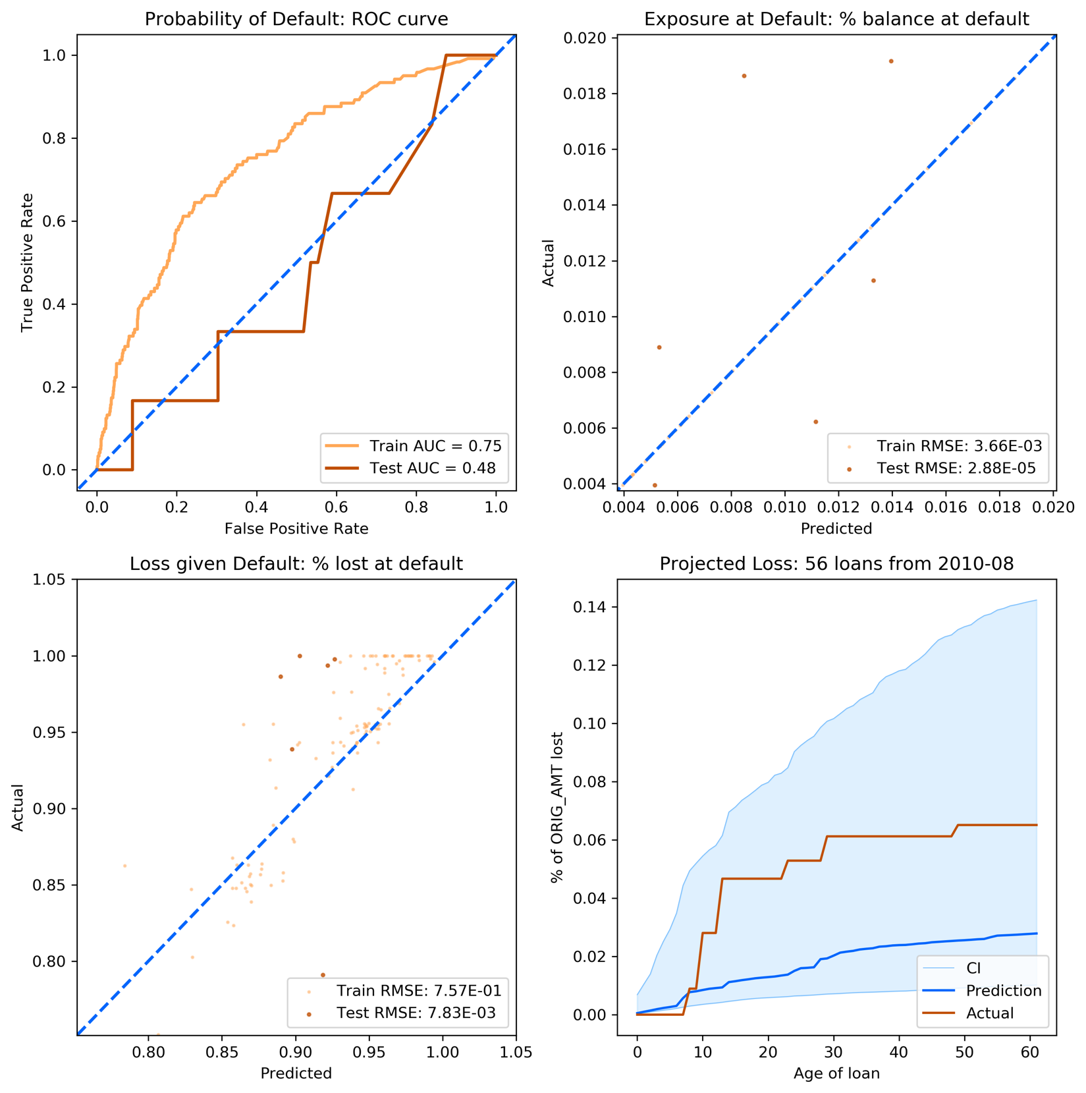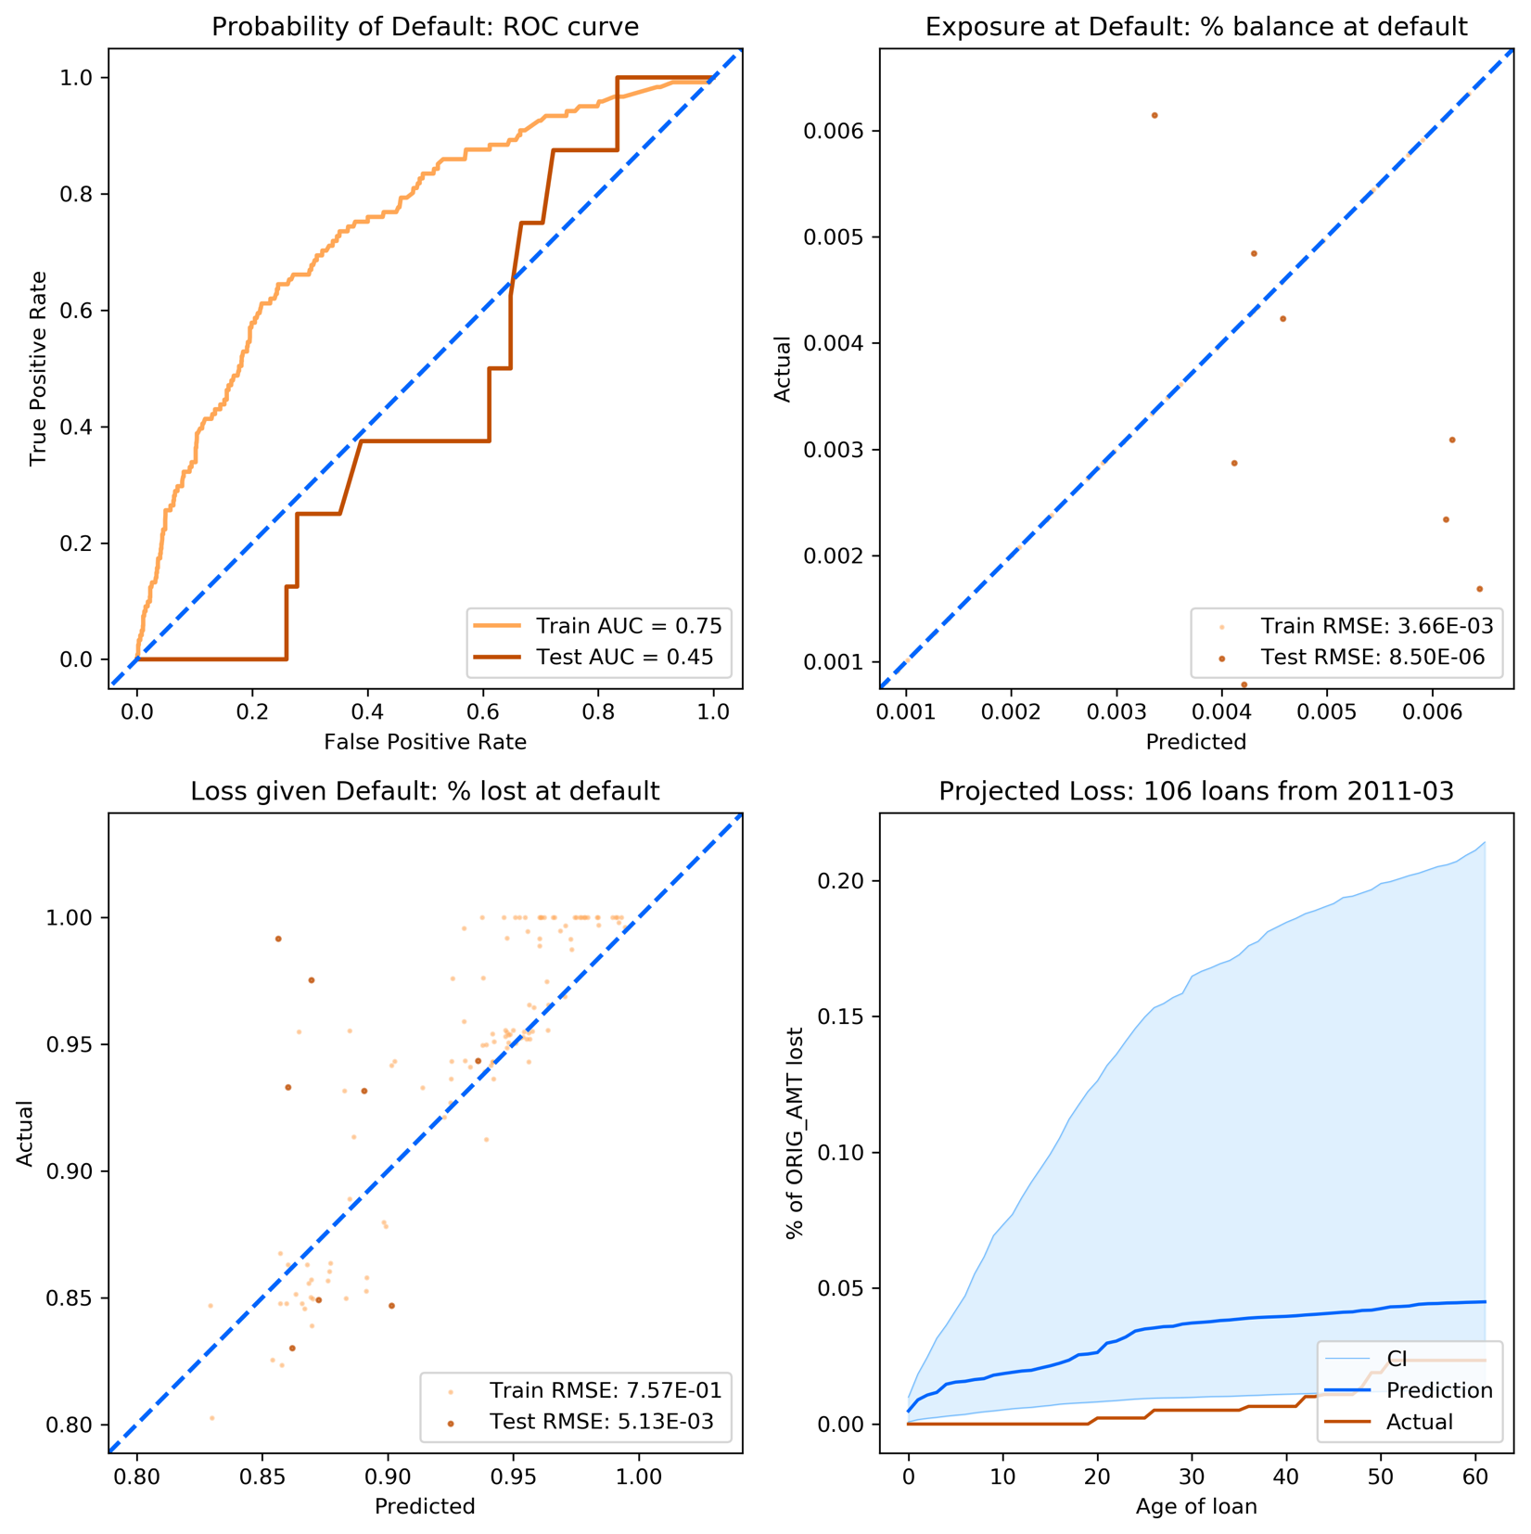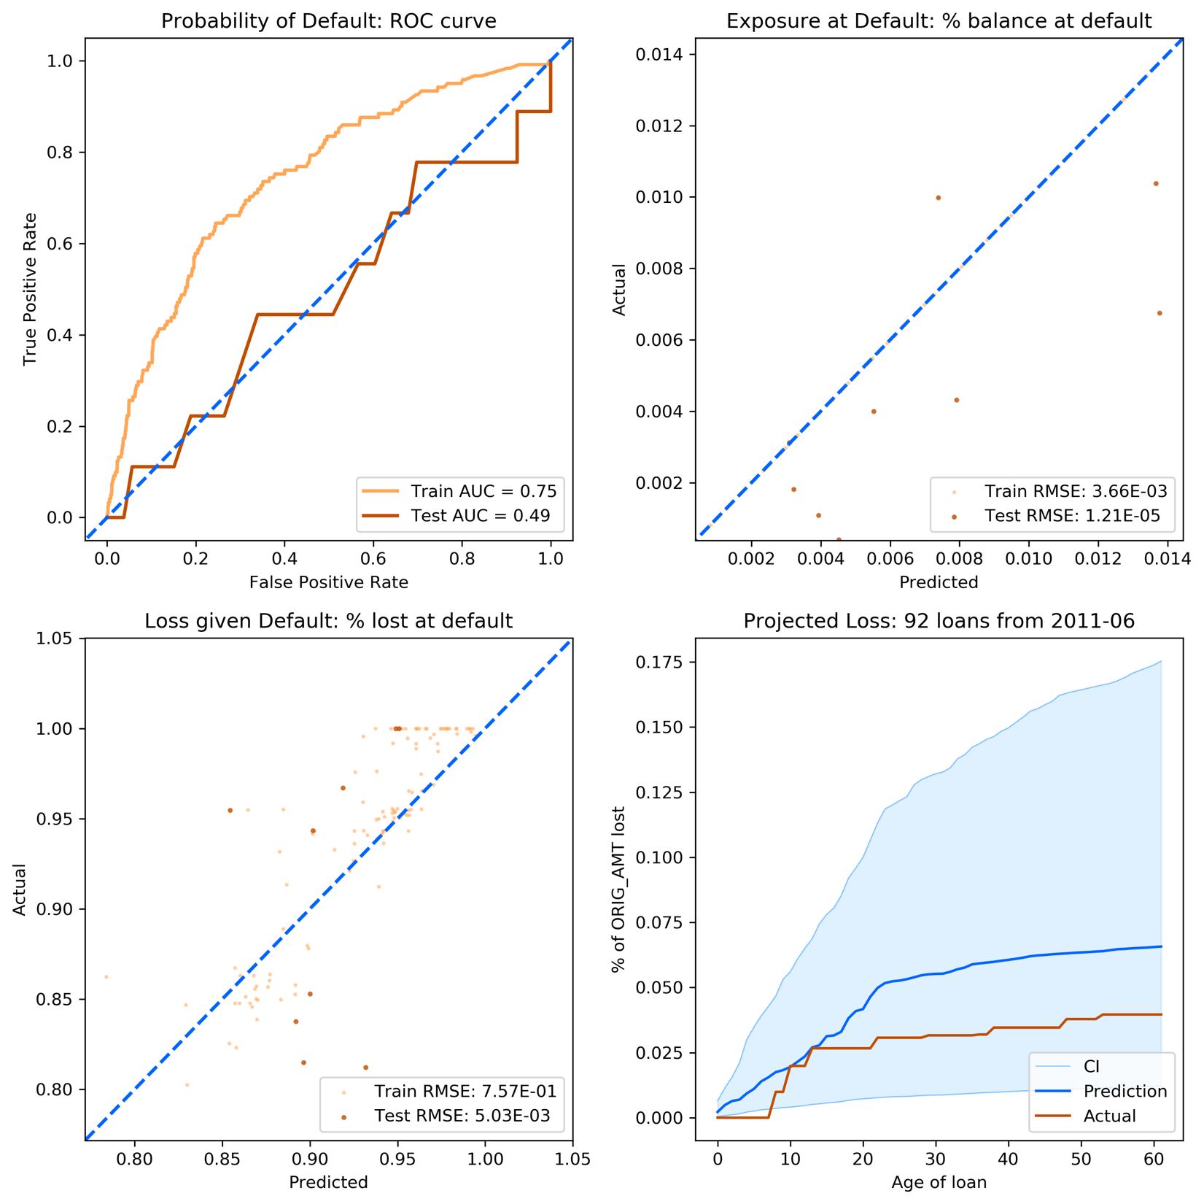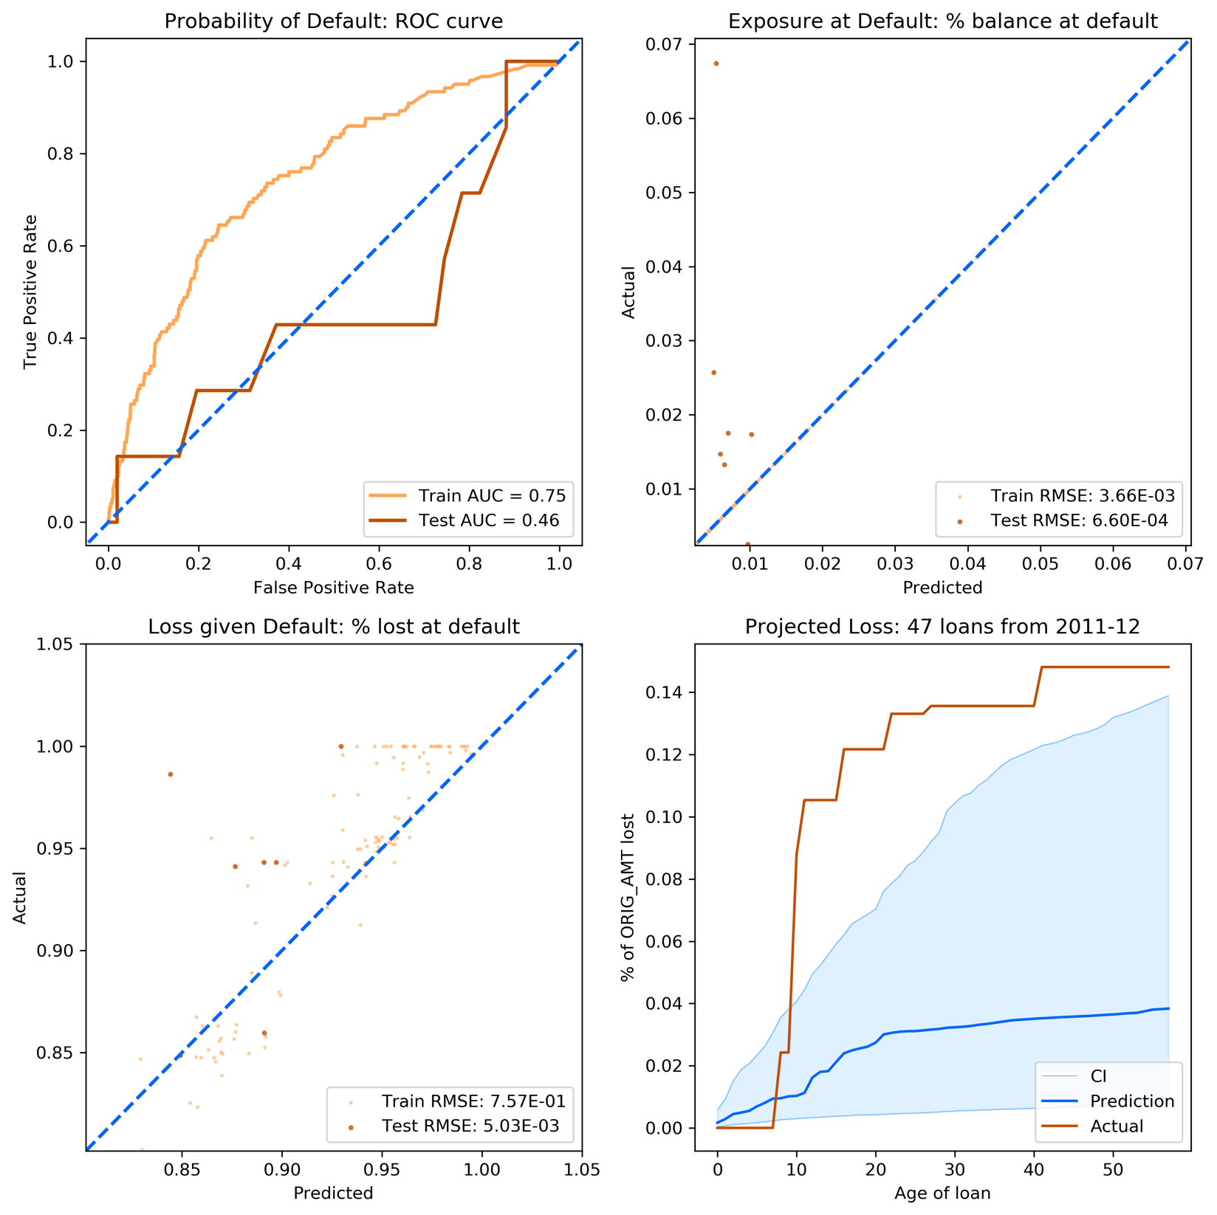

References

Leathwick, J. R., Elith, J., Francis, M. P., Hastie, T., & Taylor, P. (2006). Variation in demersal fish species richness in the oceans surrounding new zealand: An analysis using boosted regression trees.*Mar Ecol Prog Ser, 321*, 267-281. Retrieved from <https://www.int-res.com/abstracts/meps/v321/p267-281/>

Friedman JH, Meulman JJ (2003) Multiple additive regression trees with application in epidemiology. Stat Med 22: 1365–1381

Hastie, T, Tibshirani, R. and Friedman, J. Elements of Statistical Learning Ed. 2, Springer, 2009.

Sageworks. (2017). CECL Historical Loss Misconceptions. Retrieved from <https://www.sageworks.com/banking/resources/CECL-Historical-Loss-Misconceptions/>

Fannie Mae. (2018). Fannie Mae Single-Family Loan Performance Data. Retrieved from <http://www.fanniemae.com/portal/funding-the-market/data/loan-performance-data.html>